

Feed the Future

Survey Implementation

Document

Supervisor’s Manual

Zone of Influence Survey

[COUNTRY]

September 2018

This publication was prepared for review by the United States Agency for International Development. It was prepared by ICF for the United States Agency for International Development, USAID Contract Number GS-23F-8144H/AID-OAA-M-12-00006, Feed the Future PEEL.

**Recommended Citation**

Jasbir Kaur, Genevieve Dupuis, and Kiersten B. Johnson. 2018.

*Feed the Future Zone of Influence Surveys: Supervisor’s Manual.*

Washington, DC: Bureau for Food Security, USAID

**Contact Information**

Feed the Future

1300 Pennsylvania Ave, NW

Washington, DC 20004

[www.feedthefuture,gov](http://www.feedthefuture,gov)

INSTRUCTIONS TO COUNTRY MANAGER:

This document is designed as a template that can be modified for each interim ZOI Survey. The content and the text have been pre-approved by the Bureau for Food Security (BFS) and should be modified where noted. We use the following conventions in this template to indicate where modifications should or may be made:

* Where country-specific words or phrases need to be inserted, the word or concept is highlighted in yellow in the text. Substitute the appropriate word or phrase. Retain the highlighting to facilitate BFS’s review.
* Where a choice needs to be made between several text options, those options are highlighted in green. Delete the option that does not apply to your country. Retain the highlighting to facilitate BFS’s review. Add a note to the comment box confirming the customization, e.g., “To BFS: this has been customized.”
* Where a section, phrase, sentence, or paragraph may need to be customized or be deleted due to irrelevance to your country or survey, instructions are provided in a comment box. Address the instructions by adding, revising, or striking through text or a table. Highlight these additions, revisions, or strikethroughs to facilitate BFS’s review. Add a note to the comment box confirming the customization, e.g., “To BFS: this has been customized.”
* Note that Sections 5 and 6 are to be modified by the Data Quality Advisor. The Country Lead must ensure the Data Quality Advisor completes his revisions in a timely fashion so the Supervisor’s manual can be submitted to BFS by the deadline.

While in principle you should only modify the designated parts of the template, read the entire document carefully to ensure that all sections and text apply to your country. If you need to change anything other than the parts designated for modification, please use track changes to facilitate Feed the Future management’s and BFS’s review of your changes.

Table of Contents

Abbreviations v

1. Introduction 1

1.1 Purpose of this supervisor’s manual 1

1.2 Sample 1

1.3 Survey modules 2

1.4 Survey implementation 2

1.5 Confidentiality 3

1.6 Dismissal from the team 3

2. Roles and resonsibilities 4

2.1 Survey team organization 4

2.2 Responsibilities of the field supervisor 6

3. Prepare for fieldwork 6

3.1 Collect materials for fieldwork 7

3.2 Obtain monetary advances for field expenses 8

3.3 Ensure communication 8

3.4 Arrange transportation and accommodations 9

4. Organize and supervise fieldwork 10

4.1 Contact local authorities 10

4.2 Locate selected households 11

4.3 Assign interviewer designations 11

4.4 Open the cluster 13

4.5 Assign households 15

4.5.1 CAPI household assignments 15

4.5.2 Assignment sheets 15

4.5.3 Language of the interview 16

4.5.4 Hidden households 18

4.6 Reduce non-response 20

4.7 Monitor completion of assignments 22

4.8 Monitor and support interviewer performance 22

4.8.1 Observe interviews 22

4.8.2 Conduct a systematic spot-check of household composition 23

4.8.3 Conduct team meetings 26

4.9 Motivate the field team 27

4.10 Finalize work and close the cluster 27

5. Assure data quality and manage data 30

5.1 Review household form 30

5.1.1 Verify the households are complete 30

5.1.2 Confirm key height or length and weight variables 31

5.1.3 Check for age heaping in children 32

5.2 Archive data 32

5.2.1 Archive data on external memory flash drive 33

5.2.2 Archive data to Dropbox 33

6. Interactions with the central office and QCS teams 34

Annex A: Supervisor’s assignment sheet 36

Annex B: Interviewer’s assignment sheet 37

Annex C: Standard symbols used in cluster maps 39

Annex D: Screenshot of household summary 40

Annex E: Minimum and maximum expected values for children’s height/length and weight 41

Annex F: Women’s BMI chart 42

Annex G: Closing clusters guidelines 44

# List of Figures

Figure 1: Screen shot of menu to open Supervisor Entry Application 13

Figure 2: Screen shot of entering current cluster number 13

Figure 3: Screen shot of supervisor main menu 14

Figure 4: Closing and opening the cluster 14

Figure 5: Screen shot of household assignments 15

Figure 6: Screen shot of team roster 15

Figure 7: Screen shot of hidden household menu 19

Figure 8: Screen shot of hidden household numbers 19

Figure 9: Screen shot of confirmation of hidden household 20

[Figure 10: Screen shot showing the newly added household, 901, at the bottom of the   
list of households 20](file:///C:/Users/21990/OneDrive%20-%20ICF/PEEL/August-formatting%20updates/FTF%20ZOI%20Survey%20Methods%20-%20Supervisor%27s%20Manual_JK2%20-%2020180906_formatted.docx#_Toc524007335)

Figure 11: Screen shot of Bluetooth connection with interviewers 28

Figure 12: Screen shot of closing cluster dialogue box 28

Figure 13: Screen shot of closing cluster results summary indicating missing or inconsistent data 28

Figure 14: Screen shot of closing cluster results summary indicating that there are no missing or incomplete data, and that the cluster can be closed. 29

Figure 15: Screen shot of flash drive prompt 33

# List of TAbles

Table 1: Roles and responsibilities of survey team members 5

Table 2: Suggested agenda for daily field team meetings 26

# Abbreviations

BFS Bureau for Food Security

BMI Body mass index

CAPI Computer-assisted personal interviewing

CO Central office

FIES Food Insecurity Experience Scale

FTF Feed the Future

HH Household

ID Identification

IRB Institutional Review Board

IT Information technology

NFC Near field communication

ODK Open Data Kit

PAPI Paper and pencil interviewing

QC Quality Control

QCS Quality Control and Support

USAID United States Agency for International Development

WEAI Women’s Empowerment in Agriculture Index

ZOI Zone of Influence

# Introduction

Feed the Future seeks to reduce poverty, hunger, and undernutrition among women and children, and to increase income, women’s empowerment, dietary diversity, appropriate feeding practices, and resilience. Program efforts are concentrated in Zones of Influence (ZOIs) in Feed the Future target countries. Progress in achieving Feed the Future’s objectives is tracked using population-based performance indicators.

The purpose of the Feed the Future [YEAR] [COUNTRY] ZOI Survey is to provide U.S. Government interagency partners, the United States Agency for International Development (USAID) Bureau for Food Security (BFS), USAID/[COUNTRY], the [COUNTRY] government, and development partners with information on the current status of the Feed the Future population-based ZOI-level indicators. The ZOI Survey is designed to monitor progress and determine whether there has been statistically significant change over time at the population level in key outcome and impact indicators, with the expectation that the effects of the program should spread beyond beneficiaries to the general population in the ZOI over the life of the program.

## 1.1 Purpose of this supervisor’s manual

This manual describes the procedures that field supervisors should follow while leading the field teams during data collection in the field using a computer-assisted personal interviewing (CAPI) ZOI Surveys. Supervisors are responsible for teams of interviewers as they prepare for the field work, while they collect data in designated clusters, and the quality of the information collection and reporting.

## 1.2 Sample

The ZOI Survey will be conducted in areas that are representative of the households in the target population—women and children who are vulnerable to poverty, hunger, and undernutrition. For this survey, a household comprises adults and children that live together in the same dwelling. Household members can be related or unrelated, but they should meet the following criteria:



**More than one household can reside in a dwelling**



* Acknowledge the same person or persons as lead decisionmakers for the household;
* Share the same housekeeping and cooking arrangements; and
* Share the same contiguous roof.

The sample size for this survey is [NUMBER] households. The sample consists of households selected from clusters—small geographically defined areas—in the ZOI. Field teams will be given a list of clusters and households selected for interviews in each cluster. Each selected household will be visited, and all eligible members of the household will be asked to participate in the survey. For the integrity of the survey, it is extremely important that every household selected for a survey be contacted and that all eligible individuals in that household be interviewed and complete the survey. Interviewer teams will visit a household up to three times if necessary to achieve this completion. The field supervisor is responsible for ensuring that this happens in all clusters assigned to the team.

## 1.3 Survey modules

The Feed the Future ZOI Survey questionnaire for [COUNTRY] seeks information to indicate progress toward the ZOI objectives, assessed on standard indicators. The ZOI questionnaire includes the following survey modules:

* Cover and informed consent
* Module 1–Household Roster and Demographics
* Module 2–Dwelling Characteristics
* Module 3–Food Security and Resilience
* Module 4–Women’s Nutrition
* Module 4a–Women’s Anthropometry
* Module 5–Children’s Nutrition
* Module 5a–Children’s Anthropometry
* Module 6W–Empowerment in Agriculture (primary adult female decisionmaker)
* Module 6M–Empowerment in Agriculture (primary adult male decisionmaker)
* Module 7–Agricultural Technologies
* Module 8–Household Consumption Expenditure

Because survey modules 4, 4a, 5, 5a, and 6W require or are likely to have females as respondents, and because survey module 6W must be administered by a female interviewer, the household interviews will be conducted by a team of two interviewers, with at least one being female. The questionnaire will be administered in the respondent’s native language. Interviewers will administer the survey to eligible household respondents and record their responses on tablet computers.

## 1.4 Survey implementation

USAID contracted the Feed the Future [CONTRACTOR][1] to provide monitoring and evaluation support to the Feed the Future initiative. [CONTRACTOR] is providing technical assistance for the ZOI Survey, and has subcontracted with [SURVEY SUBCONTRACTOR][2] to conduct the survey. [SURVEY SUBCONTRACTOR] will plan, conduct, and supervise the fieldwork, including training and managing the field teams and ensuring the quality of fieldwork.

Feed the Future has developed extensive procedures and systems to ensure that a high quality survey is conducted. The procedures and systems documented in the *Field Supervisor’s Manual* (this manual) and *Interviewer’s Manual* must be followed as written. The field supervisor is responsible for ensuring that the field team adheres to these procedures, many of which are standard survey procedures. If a field team has questions about the procedures, the field supervisor should contact the [SURVEY SUBCONTRACTOR] field manager right away for clarification.

If a field team is unable to follow the procedures, the team should stop fieldwork and the field supervisor should contact the field manager immediately. The field manager will discuss the issue with the survey director, who in turn, if necessary, will contact the Feed the Future [CONTRACTOR] country lead to determine if any departure from these procedures is allowable.

Feed the Future [CONTRACTOR] must approve beforehand in writing any departure from these procedures. Any changes in procedures will be communicated by the Feed the Future [CONTRACTOR] country lead through [SURVEY SUBCONTRACTOR] leadership to the field supervisor.

## 1.5 Confidentiality

All data collected by the interviewers for the ZOI Survey will be confidential. The field supervisor will ensure that interviewers do not discuss household information with anyone else, other than the field supervisor and the other interviewer on the two-person interview team. The field supervisor will not discuss data from the survey, especially names of respondents or other information that could identify a respondent, with anyone other than the interviewer team that interviewed that household. During the daily debriefing meetings with the field team, the day’s challenges and successes in the field should be described and discussed as a method of improving fieldwork technique, but each team member should remain cognizant of the need to maintain respondent confidentiality.

To further ensure confidentiality, interviewers are not allowed to interview anyone they know. If an interviewer knows someone in the household, he or she should immediately inform the field supervisor. The field supervisor will re-assign that household to another interviewer.

Data will be consolidated from survey respondents for statistical reports on the results of the survey. Respondents’ names will not be reported, and it will not be possible for anyone to deduce the identity of respondents from the reports. All members of the field teams should understand this and be able to explain this to community leaders and household members.

Data from the surveys will be stored on tablet devices. Each member of the field team will have a tablet. To ensure confidentiality of the data, it is important that the location of all tablets be carefully monitored. The field supervisor must ensure that each tablet is with the team member to whom it was assigned.

## 1.6 Dismissal from the team

The field supervisor and interviewers have been carefully selected and trained by [SURVEY SUBCONTRACTOR] personnel, and the field supervisor and interviewers are expected to do high quality work and adhere to procedures throughout the survey. If this not be the case, [SURVEY SUBCONTRACTOR] will remove that person from the team.

The following actions will be grounds for immediate dismissal from the team:

* Inappropriate behavior (e.g., harassment of any kind) toward any member of the team or community;
* Falsification of any data (i.e., making up data);
* Unethical research conduct (e.g., intentional failure to obtain oral informed consent before interviewing a respondent or to maintain the confidentiality of data);
* Unauthorized use of the survey vehicle;
* Unauthorized use of tablets (e.g., downloading apps and streaming videos); or
* Attendance problems (e.g., repeated failure to show up for work as scheduled or for reported hours).

Any team member who observes any of these behaviors by other team members should notify the appropriate supervisor immediately. Interviewer performance issues should be reported to the field supervisor. Field supervisor performance issues should be reported to the QCS team or the field manager. The implicated team member will have the opportunity to defend himself or herself against the accusation before removal from the team. If removal is warranted, [SURVEY SUBCONTRACTOR] management will arrange for immediate replacement of the team member.

Field supervisors or interviewers also will be dismissed if they repeatedly fail to follow any of the procedures outlined in the *Field Supervisor’s Manual* or the *Interviewer’s Manual*. That individual’s supervisor should bring the problem behavior to the individual’s attention and provide instruction or guidance on how to adhere to the procedures. The supervisor should keep track of the occurrences when the problem behavior was discussed with the individual and the efforts made to improve performance. If the problem behavior does not improve after several attempts, the supervisor will report this to [SURVEY SUBCONTRACTOR] management, which will arrange for replacement of the team member.

# Roles and resonsibilities

## 2.1 Survey team organization

Roles and responsibilities for the survey are shared between the team in the central office of the [SURVEY SUBCONTRACTOR] and field teams. The team at the central offices of [SURVEY SUBCONTRACTOR] will include the survey director, field manager, assistant field manager, in-country data manager, and the information technology specialist. The data collection field teams consist of a field supervisor, four social science interviewers, an agriculture interviewer and a driver. Every household interview will be conducted by an interviewer team that consists of two social science interviewers; if the household raises livestock or cultivates crops, the field team’s agriculture interviewer will collect data for the agriculture modules. Quality Control and Support (QCS) teams will travel among the data collection field teams to provide logistical support and monitor data quality. Table 1 lists the roles and responsibilities of team members.

Table 1: Roles and responsibilities of survey team members

| **Staff Role** |  | **Staff Responsibilities** |
| --- | --- | --- |
| CENTRAL OFFICE | | |
| Survey Director |  | The survey director is responsible for ensuring that all aspects of survey operations are implemented according to protocol and that the survey is completed on schedule and within budget. |
| Social Science Survey Field Manager |  | The social science survey field manager is responsible for coordinating and managing field operations, including the hard copy questionnaire pretest, listing, survey pretest, pilot, and main fieldwork. The field manager manages the fieldwork schedule, ensures field teams have the required resources, and monitors completion of all work. |
| Agriculture Survey Field Manager |  | The agriculture survey field manager is responsible for leading the coordination and management of data collection related to the agriculture component of the study, including the hard copy questionnaire pretest, survey pretest, pilot, and main fieldwork. |
| In-Country Data Manager |  | The data manager will respond to data quality reports generated in the field and communicate any problems that are discovered to field supervisors and survey management. The data manager will report the nature and scope of these problems and suggest solutions. |
| Information Technology Specialist |  | The information technology specialist will liaise with the technical teams and local non‑technical staff to ensure the technology being used to implement the survey is available, functional, and well understood. Duties include survey hardware oversight, (customs procedures as appropriate, maintenance, tracking); management of questionnaire updates; leveraging local networks for optimal data delivery; technical re-training for field staff as needed; and task-appropriate configuration, security, and training for non-survey hardware. |
| QCS TEAMS | | |
| Quality Control and Support Teams |  | Rotating regional QCS teams will visit the field teams once each week. The QCS teams will include an agriculture supervisor, who will observe data collection for the agriculture survey module, including GPS-based plot area measurement; and a social science supervisor, who will observe the social interviewers’ work. The objective of the QCS teams will be to provide quality assurance and also to provide any material or moral support that the field teams need. The number of QCS teams required to provide appropriate coverage will be determined by the size and geographical distribution of the fieldwork. |
| FIELD TEAMS | | |
| Field Supervisor |  | Each field team has one field supervisor. The field supervisor is responsible for the field team and the day-to-day organization and supervision of the team’s work. The field supervisor assigns households to interviewers, monitors completion of the work, ensures that all field team members adhere to required procedures, observes interviews, and conducts listing and household roster spot-checks. The field supervisor also meets with community leaders, manages the vehicle and driver, and coordinates room and board for the team. |
| Interviewers |  | Each field team will comprise five interviewers: two teams of two social survey interviewers each, plus an agriculture survey specialist. Each team of social survey interviewers will comprise one female and one male interviewer, with the dedicated agriculture specialist (male or female) working in coordination with the two-interviewer teams. The agriculture specialist will be responsible, in tandem with one of the other two interviewers, or alternatively the team supervisor, for conducting the agriculture interview (questionnaire Module 7) and measuring the cultivated plots for all eligible households. Interviewers will be responsible for successful and accurate completion of all assigned interviews. |
| Driver |  | Each field team is accompanied by one driver, who ensures that the field team safely arrives at the selected survey clusters and returns to the central office. If the dwellings in a cluster are at a distance apart, the driver takes the interviewers from household to household. |

## 2.2 Responsibilities of the field supervisor

A field supervisor has an important position as the senior member of the data collection field team. The field supervisor is responsible for ensuring that the survey is completed according to procedures in the assigned clusters, that the field team is adequately supported, and that the team maintains high quality standards.

This manual documents the responsibilities of the field supervisor and provides detailed instructions on how to fulfill those responsibilities. The field supervisor should feel free to contact the field manager or QCS team members with any questions or to discuss any issues that were not covered by procedures or training.

In addition to understanding their own responsibilities, the field supervisors must have a complete, in-depth understanding of the questionnaire and know how to manage the interviews on the tablet computers. The field supervisors also need to monitor the interviewers’ performance, serve as a resource to interviewers on the questionnaire and tablet computers, and review the quality of the interviewers’ work. To this end, the field supervisor also will receive training on the *Interviewer’s Manual*. The field supervisors should carry copies of the *Field Supervisor’s Manual* and the *Interviewer’s Manual* for both social science interviewers and agriculture interviewers for reference in the field.

# Prepare for fieldwork

Thorough preparation for fieldwork is a necessary step that will enable the field team to complete its assignments efficiently. To prepare for fieldwork, the field supervisor will review with the field manager the field team’s assigned clusters and maps or satellite images of those clusters. The field supervisor will review the schedule for completing fieldwork in each cluster and plan for data transmission from clusters that are likely to lack Internet or mobile telephone access. The field supervisor should become familiar with the clusters where the team will be working and determine the best arrangements for travel and accommodations. The field supervisor should obtain all monetary advances, supplies, and equipment necessary for the team to complete its assigned interviews.

## 3.1 Collect materials for fieldwork

Before leaving for the field, the field supervisor must verify the field team has adequate supplies of the materials the team will need in the field. These items are listed below.

[SURVEY SUBCONTRACTOR] will create a list of field teams and their members. The list will include the mobile telephone number of the field supervisors and the languages spoken by each field team member. [SURVEY SUBCONTRACTOR] also will maintain emergency contact information for all field team members. The field supervisor will be given copies of these lists.

Also, [SURVEY SUBCONTRACTOR] will prepare documentation and assemble sample measuring items that will be used to help respondents quantify food consumption. These are laminated cardstock showing images of major food items in different sizes and sets of standard items used to measure food, such as a cup or a bushel container.

The following lists show the documents and material supplies that field supervisors should verify are available to the field teams:

Fieldwork documents:

* *Field Supervisor’s Manual*,
* *Interviewer’s Manuals* (each interviewer should have his or her own copy and the field team should have several spare copies as replacements),
* *Anthropometry Manual* (one per interviewer),
* Lists of clusters assigned to the field team,
* Lists of selected households in each cluster and maps or satellite images of those clusters showing the selected households,
* Listing data (copies of completed listing forms) for the clusters assigned to the field team,
* List of local authorities in clusters assigned to the field team,
* Letter of introduction from the [MINISTRY],
* Paper copies of the questionnaire in all languages that are the native language of 10 percent or more of the population in the assigned clusters,
* Documents to be used in the cluster *[Note: All completed documents will be returned to the central office.]*,
* *Supervisor’s assignment sheets* (one for each assigned cluster, plus spares),
* *Interviewer’s assignment sheets* (one for each interviewer for each cluster, plus spares),
* *Informed consent forms* (one for each assigned household, plus spares),
* *Spot-check package* (cover and consent form and survey module 5 only; at least three per cluster, plus spares),
* *Vehicle mileage and expenditure log* forms,
* List of phone numbers of field supervisors and the languages spoken by their teams (to be used in case of emergency or to identify an interviewer who speaks a language not spoken on the field team), and
* List of emergency contact information for all field team members.

Supplies:

* Identification for each field team member;
* Clipboards, briefcases, backpacks;
* Necessary supplies for paperwork in the cluster (e.g., paper clips, pen and pencils, staplers and staples, and tape);
* First aid kit;
* Waterproof containers and envelopes to store documentation;
* Portable seca® scales (model 881) and ShorrBoards® for measuring (two of each);
* Batteries for seca scales (eight AA batteries);
* Laminated anthropometry ranges (three);
* Laminated yellow-orange card showing the color of orange-fleshed sweet potato (three);
* Laminated cardstock with images of major food items of different sizes (three sets);
* Set of common measuring tools (e.g., measuring cups, bushel containers) (three sets);
* Tablet computers (set up and configured) and carrying cases, with matching IDs for the interviewer and the tablet (total of six: one for the field supervisor one each for the four social science interviewers, and one for the agriculture interviewer);
* Barcodes
* Shovel
* Plastic spray bottles
* Equipment for charging multiple tablets at a time, including wall adapters and car chargers if needed;
* Mobile phone with SIM card and phone charger; and
* Wi-Fi hot spot.

## 3.2 Obtain monetary advances for field expenses

The field supervisor is responsible for handling payments for field team members, the vehicle, and other necessary expenses in the field. The field supervisor should have sufficient funds to cover expenses for the team during fieldwork. Funds should be distributed according to the procedures established by [SURVEY SUBCONTRACTOR].

Receipts for items like fuel and any vehicle repairs are required for reimbursement from Feed the Future [CONTRACTOR]. The field supervisor should carefully note all such purchases and provide receipts to the central office.

## 3.3 Ensure communication

The field manager and field supervisor should develop a regular schedule for phone communications before the field team leaves for the field. Daily contact by phone is preferred if telephone communication is possible, which will allow the central office staff and field supervisors to provide adequate support and supervision of the field team.

If cellular service, Wi-Fi, or landline coverage is available, the field manager and the field supervisor should be in contact by telephone daily. The field supervisor will advise the field manager as the team is preparing to finish work in a cluster. Before the field team leaves the cluster, the field supervisor will confirm with the field manager that all data from the cluster have been received by the Feed the Future [CONTRACTOR] and work in the cluster is considered complete. The field supervisor will advise the field manager when the field team arrives in a new cluster.

If no cellular service, Wi-Fi, or landline coverage is available, the field supervisor should travel to another location that has service and call the field manager at least once a week or when necessary to discuss an important fieldwork topic or to request support.

As an alternative, if phone service is not available, the QCS team can serve as the communications conduit. If necessary, the field manager should depart from the regular QCS team visit schedule and deploy the QCS team to a cluster where no phone service is available to prevent a break in communication with that field team.

Remote clusters that are expected to lack cellular service, Wi-Fi, or landline coverage will be identified during the listing process before the fieldwork begins. For these clusters, the field manager and field supervisor will plan the expected dates and locations for data transmission to the Feed the Future [CONTRACTOR].

## 3.4 Arrange transportation and accommodations

The field supervisor will work with the central office to make all necessary travel arrangements for his or her team.

The field supervisor will ensure the vehicle is used for survey work only and is adequately maintained. The field supervisor will direct the work of the driver, including planning the drop off and pick up of field team members as they conduct their daily interviewing activities. The field supervisor will keep track of all transportation-related costs and mileage and retain receipts for all fuel and other vehicle-related expenses. These receipts are required for reimbursement and will be provided to the field manager or to the QCS team, whichever the field supervisor sees first.

As necessary, the field supervisor will make arrangements for alternative modes of transportation in the field, such as boat or horseback. The field supervisor also will ensure that field team members have food and lodging that is comfortable, secure, and located close to the cluster.

The field supervisor will try to arrange lodging that supports nightly recharging of the tablet computers. If this is not possible, the field supervisor will plan an alternative approach, such as charging tablet computers using the car battery.

It is possible that security problems, road blockades, difficult terrain, or natural disasters will block access to a cluster in the sample. The supervisor should immediately inform the field manager of any difficulty in gaining access to an entire cluster or dwellings in a selected cluster. In some extreme cases, it may be necessary to replace an entire cluster due to lack of accessibility. [CONTRACTOR] has selected a list of alternate clusters to cover these situations when a primary cluster is unavailable. In these cases, the supervisor should contact the field manager to request a replacement cluster and to inform him or her about the reasons for requesting a replacement. The field manager should then contact the survey director and the field manager. If the case merits a change, [CONTRACTOR] will provide a replacement cluster to the [SURVEY SUBCONTRACTOR], ensuring that the sampling statistician is notified of the action.

# Organize and supervise fieldwork

Supervisors are responsible for the interviewers during fieldwork and the quality of the information collected and reported. Following is a list of the field supervisor’s responsibilities during fieldwork:

* Contact local authorities,
* Locate selected households,
* Assign interviewer designations,
* Open and close clusters,
* Assign households,
* Reduce non-response,
* Monitor completion of assignments,
* Monitor and support interviewer performance,
* Maintain interviewer motivation and morale, and
* Finalize work and close cluster.

These responsibilities are discussed in the next sections.

## 4.1 Contact local authorities

The field supervisor should contact the local authorities before starting fieldwork in a cluster and seek their support for the survey. The field supervisor will also ask about market days or other events that will impact scheduling. With this information and the support of local authorities, the field team’s work will be facilitated and community members’ willingness to participate in the survey will be enhanced.

The field manager will give the field supervisor a list of local authorities and their contact information before leaving for the field. The field supervisor should check whether a letter of introduction has already been provided to the local authorities before the start of fieldwork, such as during listing. If the letter of introduction has been sent to local authorities, the field supervisor needs a copy of that letter to show to the local authorities.

When meeting with local authorities, the field supervisor should use the appropriate honorific titles and express the team’s appreciation for being allowed to conduct the survey in the community. The field supervisor will provide the local authorities with a copy of the letter from the [MINISTRY]. If the local authorities show any reluctance to allow the fieldwork to be conducted, the field supervisor should explain these points:

* The study has been approved by the central government, as documented in the letter from the [MINISTRY].
* The survey will improve the government’s knowledge of the food security situation and the nutritional status of women and children in the area, which is to the long-term benefit of the community.
* There is no cost to the community or to any respondent.
* Respondents’ identities will be protected absolutely, and only aggregated results will be published.
* Respondents have the right to refuse to participate in the survey or to answer any question without recrimination, and they can end the interview at any time.

If the local authorities are reluctant, the field supervisor should contact the survey director and ask the survey director to speak with the local authority directly or to intervene through other official channels.

## 4.2 Locate selected households

On arriving in a cluster, the field supervisor should locate several major boundary features to make sure the field team is in the right location. In most clusters, the boundaries will be easily recognizable features such as streams, lakes, roads, or railroads. (See Annex C for a list of symbols used on maps.) In urban areas, the maps will include street names to help pinpoint locations. If there is any difficulty determining the boundaries of the cluster, the field supervisor should consult with the [SURVEY SUBCONTRACTOR] listing coordinator, or request the help of local authorities in locating boundaries. After the field supervisor is certain of the cluster boundaries, he or she should orient the field team, including the driver, to those boundaries, pointing them out on the map or satellite image.

While making assignments each day, the field supervisor should point out the assigned households on the map or satellite image to each interviewer team and the driver. The households on the map or satellite image will be numbered so that it will be possible to find the assigned household ID number on the map or satellite image. The field supervisor should discuss with the interviewers and driver the landmarks that will help locate the household.

The field supervisor should manage the driver’s time so that the vehicle is available for drop off and pick up of interviewer teams, especially teams working in the more remote locations.

## 4.3 Assign interviewer designations

The social science interviewers will work in households in teams of two. This will enhance the security of the interviewers, improve the quality of the interview, allow team members to share the burden of administering a long questionnaire, and provide the necessary support for taking anthropometric measurements. The agriculture interviewer will work with both interviewing teams to collect data on the agriculture modules, including field measurements.

The field supervisor will assign one interviewer, designated as Interviewer A, to the household, along with a second interviewer, designated as Interviewer B. Interviewer A will take the lead role in a selected household and will be responsible for administering the household roster, assigning the survey modules to Interviewer B, and agriculture modules to the agriculture interviewer, receiving completed modules from Interviewer B and the agriculture interviewer, and transmitting completed questionnaires to the field supervisor. Survey module assignment is meant to delineate the division of labor in a selected household. The designation will be made on an equitable basis and interviewers will alternate in subsequent households as Interviewer A and B.

The assigned Interviewer A will have the following responsibilities:

* List that household and track progress in the interview completion on the interviewer’s assignment sheet;
* Be responsible for beginning the interview at the assigned household;
* Assign survey modules to Interviewer B, and agriculture modules to the agriculture interviewer;
* Receive completed modules from Interviewer B and the agriculture interviewer;
* Ensure that all data for that household are on Interviewer A’s tablet;
* Maintain the paperwork (i.e., the *anthropometry and plot and land area measurement* forms) for that household;
* Ensure that the questionnaire is completed in that household, including returning for call-back visits as necessary; and
* Submit the completed paperwork and transmit the completed questionnaire from Interviewer A’s tablet to the field supervisor’s tablet for review.

If the team comprises two female interviewers, then the labor is divided this way:

1. Interviewer A will collect data for survey modules 1, 2, 6W, and 8.
2. Interviewer B will collect data for survey modules 3, 4, 4a, 5, 5a, and 6M.
3. The agriculture interviewer will collect data for survey module 7.

In the next household, Interviewer B will serve in the capacity of Interviewer A.

If the team comprises one male and one female interviewer, then the labor is divided this way:

1. The male interviewer will serve as Interviewer A. He will collect data for survey modules 1, 2, 6M, and 8.
2. The female interviewer will serve as Interviewer B and collect data for survey modules 3, 4, 4a, 5, 5a, and 6W.
3. The agriculture interviewer will collect data for survey module 7.

In the next household, to ensure that the female interviewer remains responsible for asking module 6W, which has gender-sensitive questions, and to also ensure that the labor is divided equitably, the labor will be divided this way:

1. The female interviewer will serve as Interviewer A. She will collect data for survey modules 1, 2, 6W, and 8.
2. The male interviewer will serve as Interviewer B and collect data for survey modules 3, 4, 4a, 5, 5a, and 6M.
3. The agriculture interviewer will collect data for survey module 7.

NOTE: These scenarios serve as an example. During fieldwork, you will consider multiple factors, including call-backs, absentees, etc. to ensure that interviews are conducted in an equitable manner.

It may be necessary to return to some households multiple times to conduct call-backs to interview all eligible respondents. Establishing rapport with respondents is critical to the success of the interview. For this reason, the same Interviewer A must return to the household for call-backs—accompanied by the same Interviewer B when possible, but Interviewer A can be joined by a different Interviewer B if need be.

## 4.4 **Open the cluster**

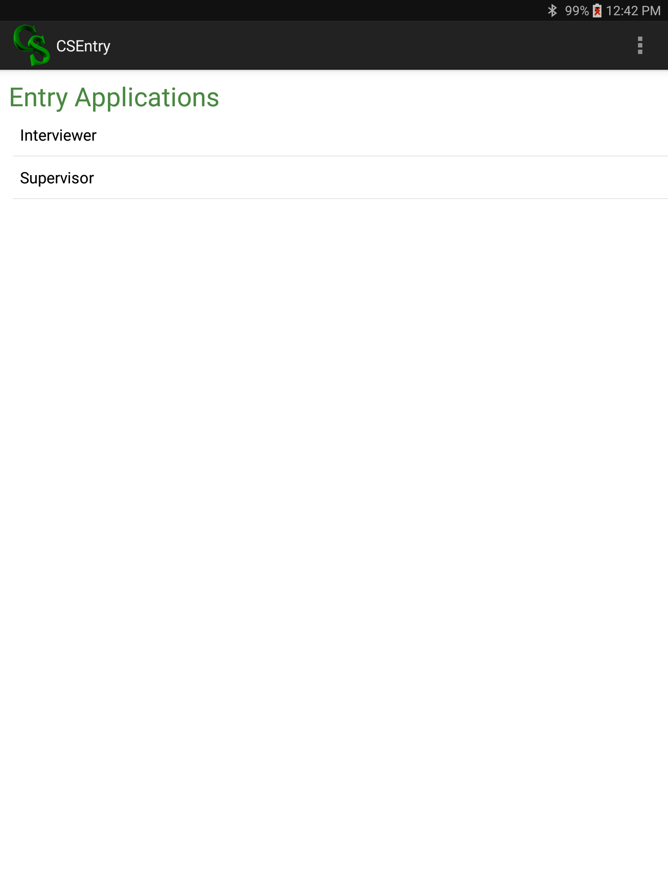

Figure 1: Screen shot of menu to open Supervisor Entry Application

When the team arrives in the cluster, the field supervisor will use the **Supervisor Application** to open and select the cluster (Figure 1).

Only the field supervisor has the capability to open the cluster and close the completed clusters after data collection is complete.

This system controls permissions for data collection for a given cluster.

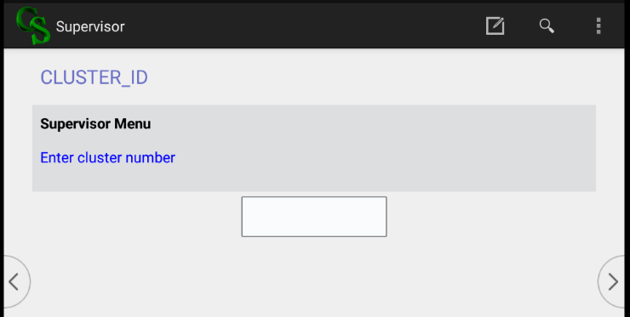

Figure 2: Screen shot of entering current cluster number

*[Note: It is necessary to close a completed cluster to avoid unwanted changes to the data].*

First, enter the current cluster number (Figure 2).

After selecting the current cluster number, the main selection menu for the supervisor appears. If it is the first time working in the cluster, or it is time to close the cluster after all work is completed, select menu option **“1. Open/Close Cluster”** from the main menu for supervisors (Figure 3).

Figure 3: Screen shot of supervisor main menu

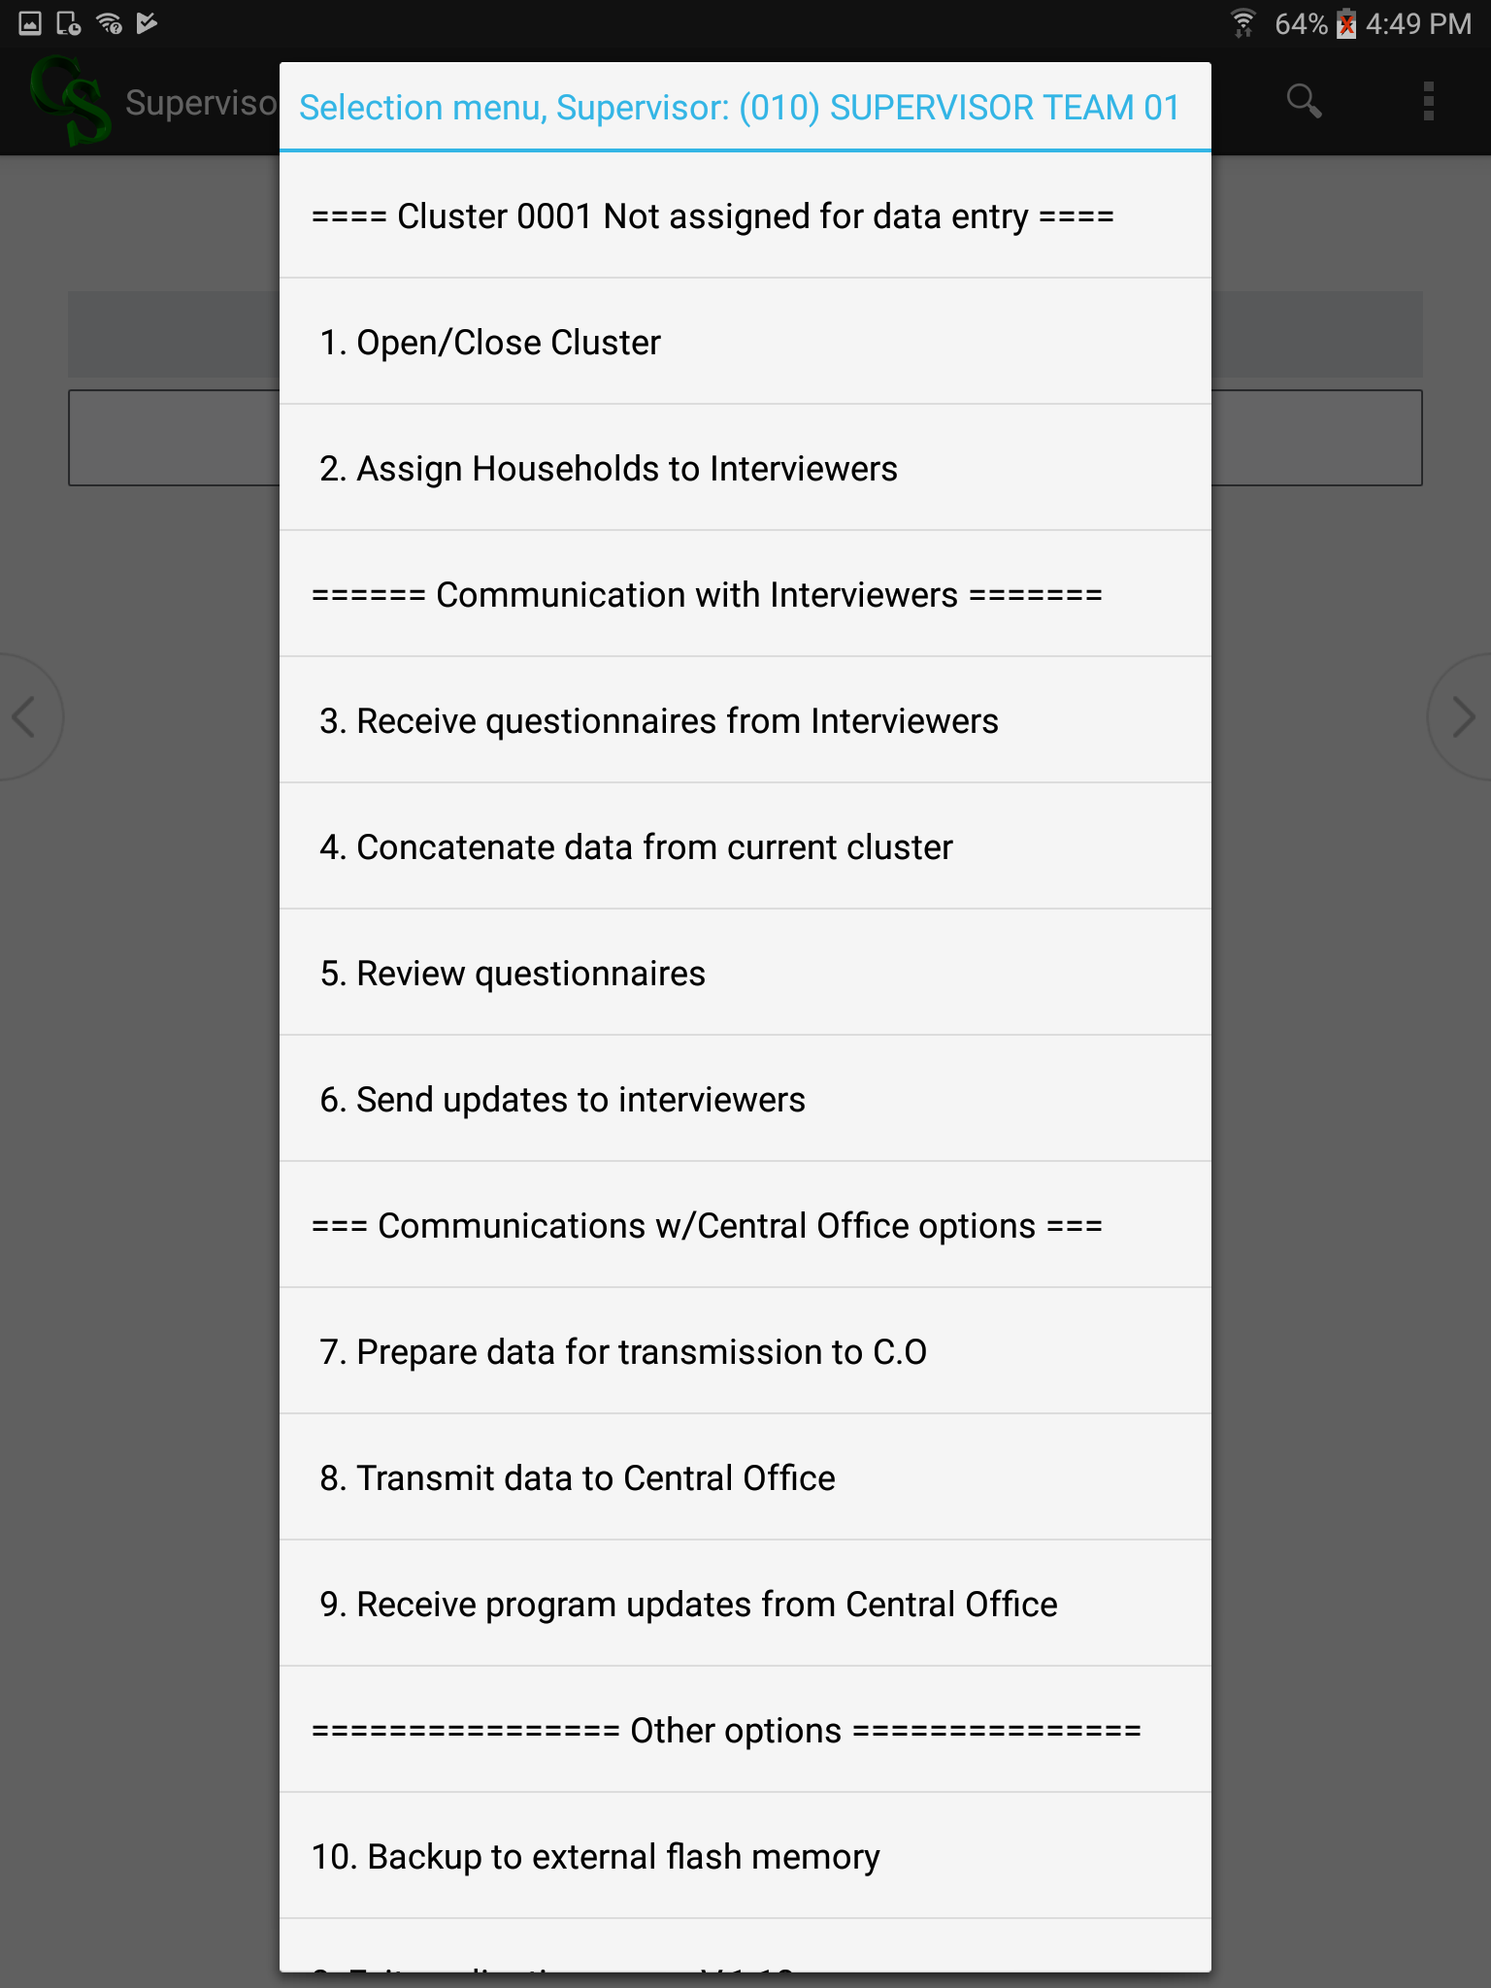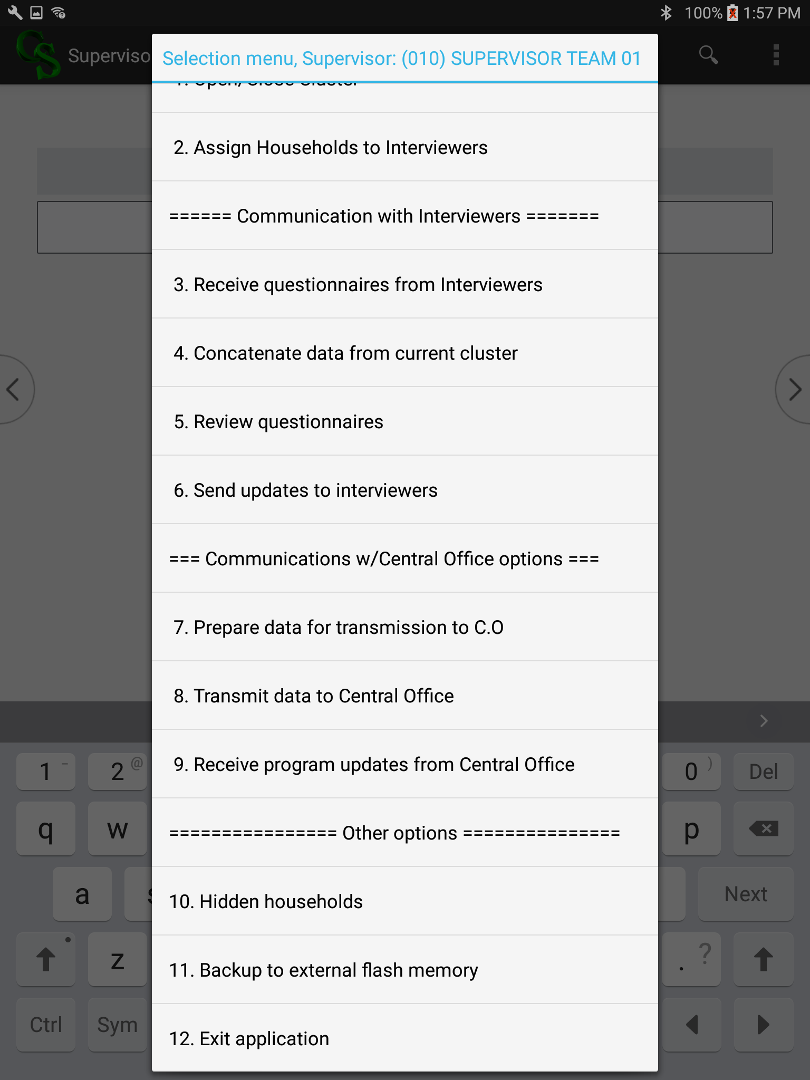

If the cluster was not open, the system will ask if you want to open the cluster; if it was open, the system will ask if you want to close the cluster. If the cluster is already in progress, the field supervisor should select “No” and continue work (Figure 4). *[Note: The field supervisor should use the option of closing the cluster ONLY after the data collection for the cluster has been completed, reviewed, and verified to be correct.]*

Figure 4: Closing and opening the cluster

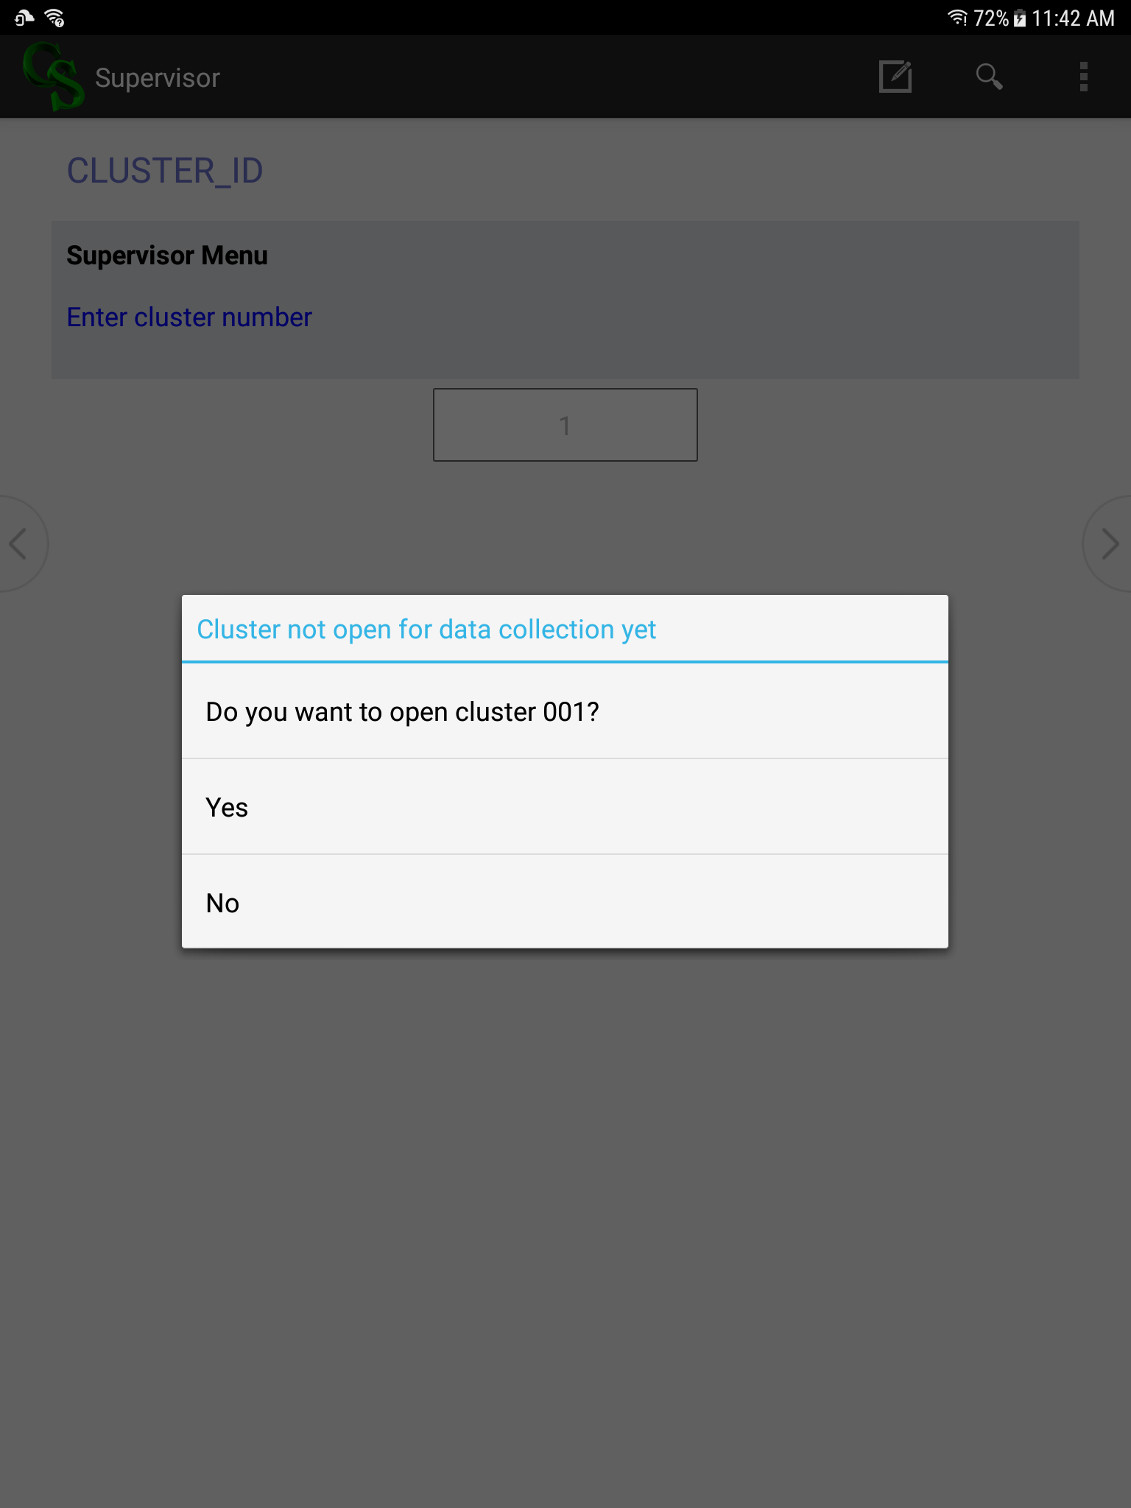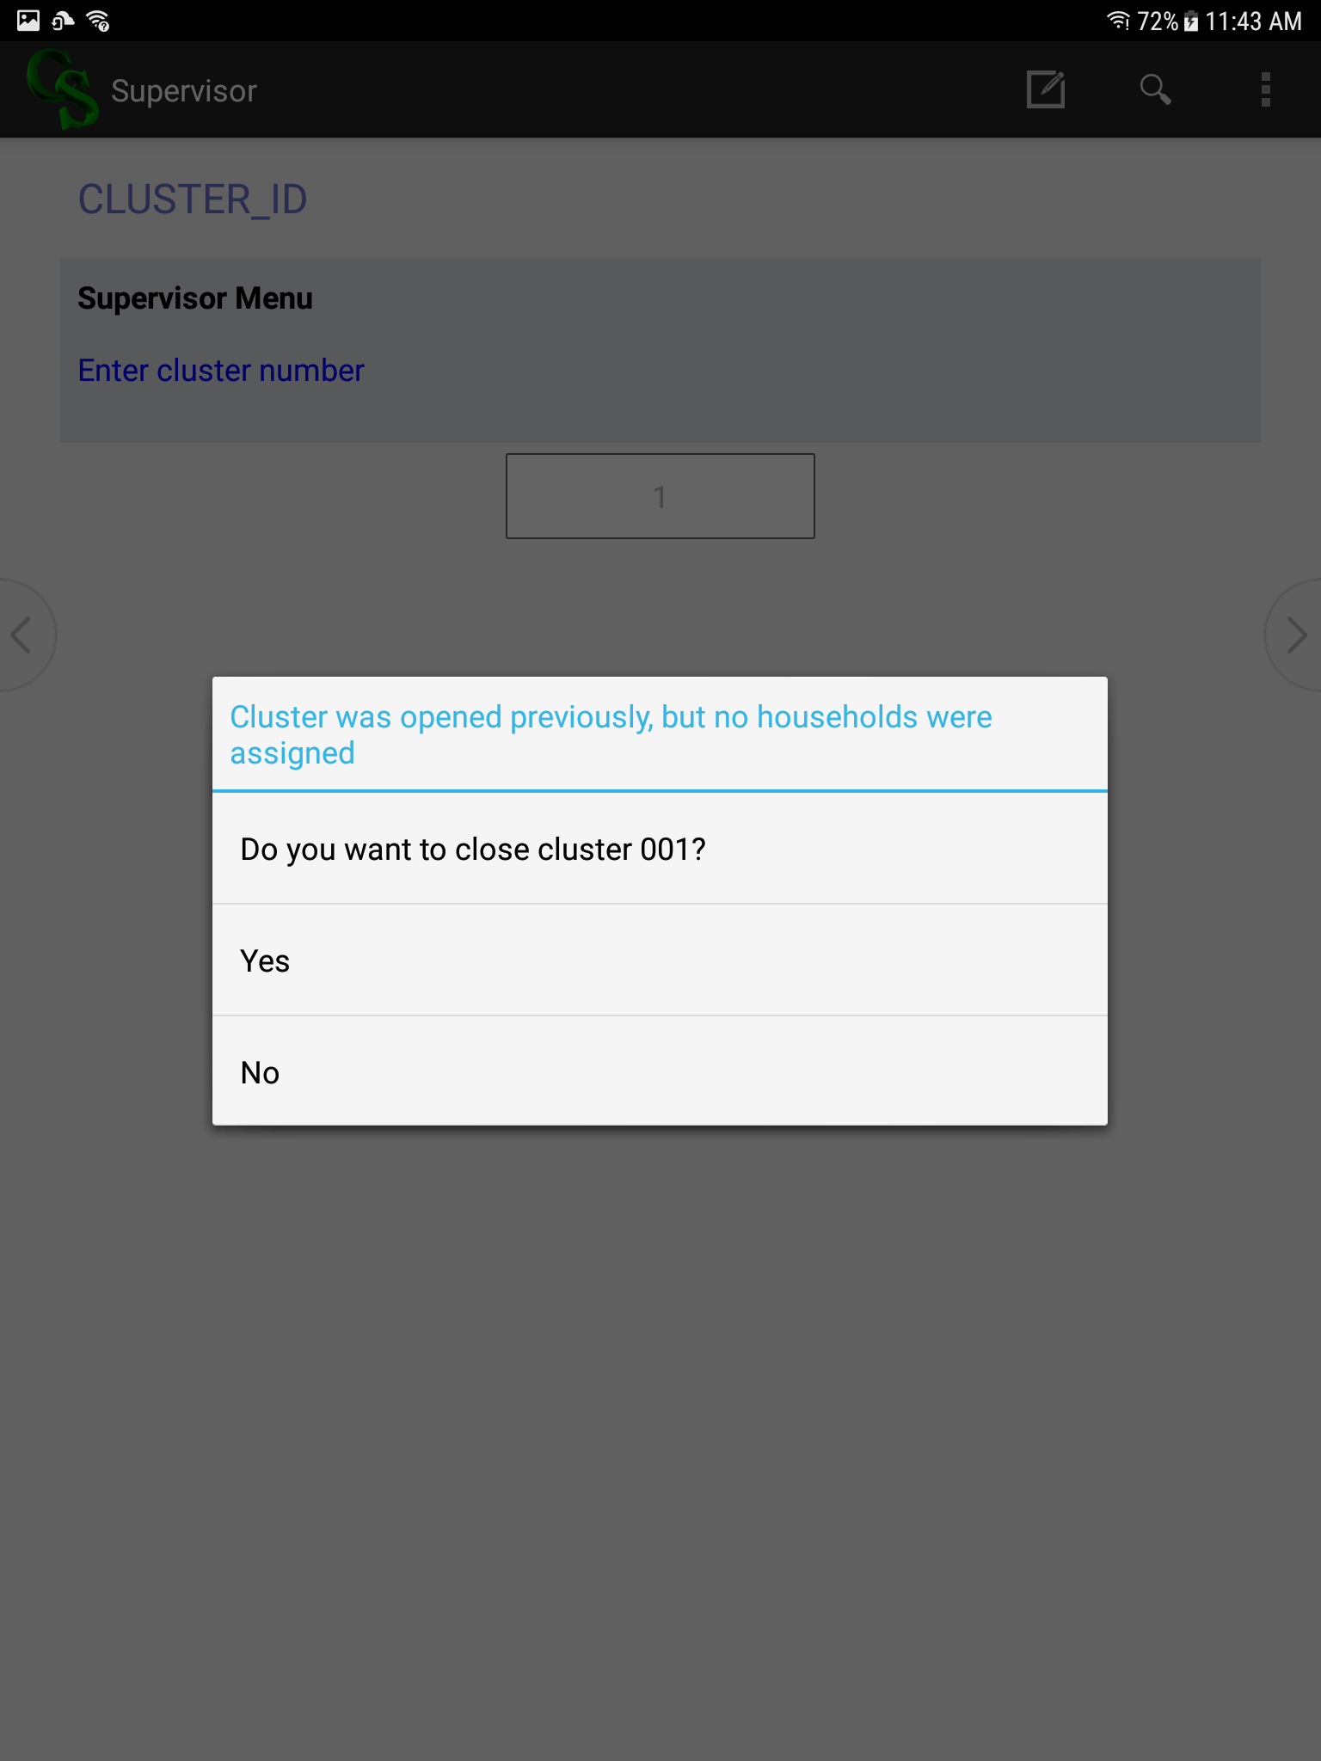

In case the supervisor makes an error in the order of procedures (e.g., attempting to close a cluster before assigning any interviewers), the system shows an error and won’t allow the field supervisor to continue out of sequence.

## 4.5 Assign households

The field supervisor is responsible for assigning households to interviewers so that all interviews are completed on time. In general, interviewer teams should be able to complete an average of two household interviews per day, depending on distances between dwellings and the number of eligible respondents and their availability.

The field supervisor will make work assignments daily to manage the workload and pace of data collection. The field supervisor will need to assign households carefully to ensure Interviewer A is able to complete all household visits, including call-backs. The field supervisor will ensure that the agriculture interviewer is well-coordinated to work with households eligible for the agriculture modules, including ensuring the driver’s availability to transport the agriculture interviewer and the respondent to the farmer’s plot, as needed.

### 4.5.1 CAPI household assignments

Figure 5: Screen shot of household assignments

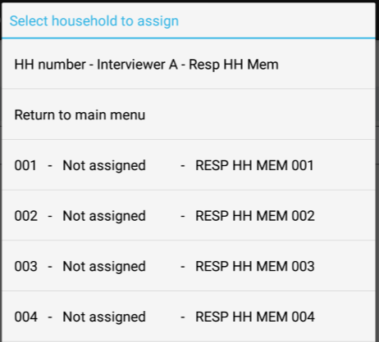

To assign households in the CAPI system, the field supervisor will select option, **“2. Assign Households to Interviewers”**, from the Supervisor Menu, and options for assignments appear (Figure 5). The field supervisor first selects the household that he/she would like to assign, then chooses the option to select an interviewer.

The list of team members will appear and the supervisor should choose a team member to assign as Interviewer A (Figure 6). The supervisor will repeat the process for each household they would like to assign. After each assignment, the household listing in Figure 5 is updated.

Figure 6: Screen shot of team roster

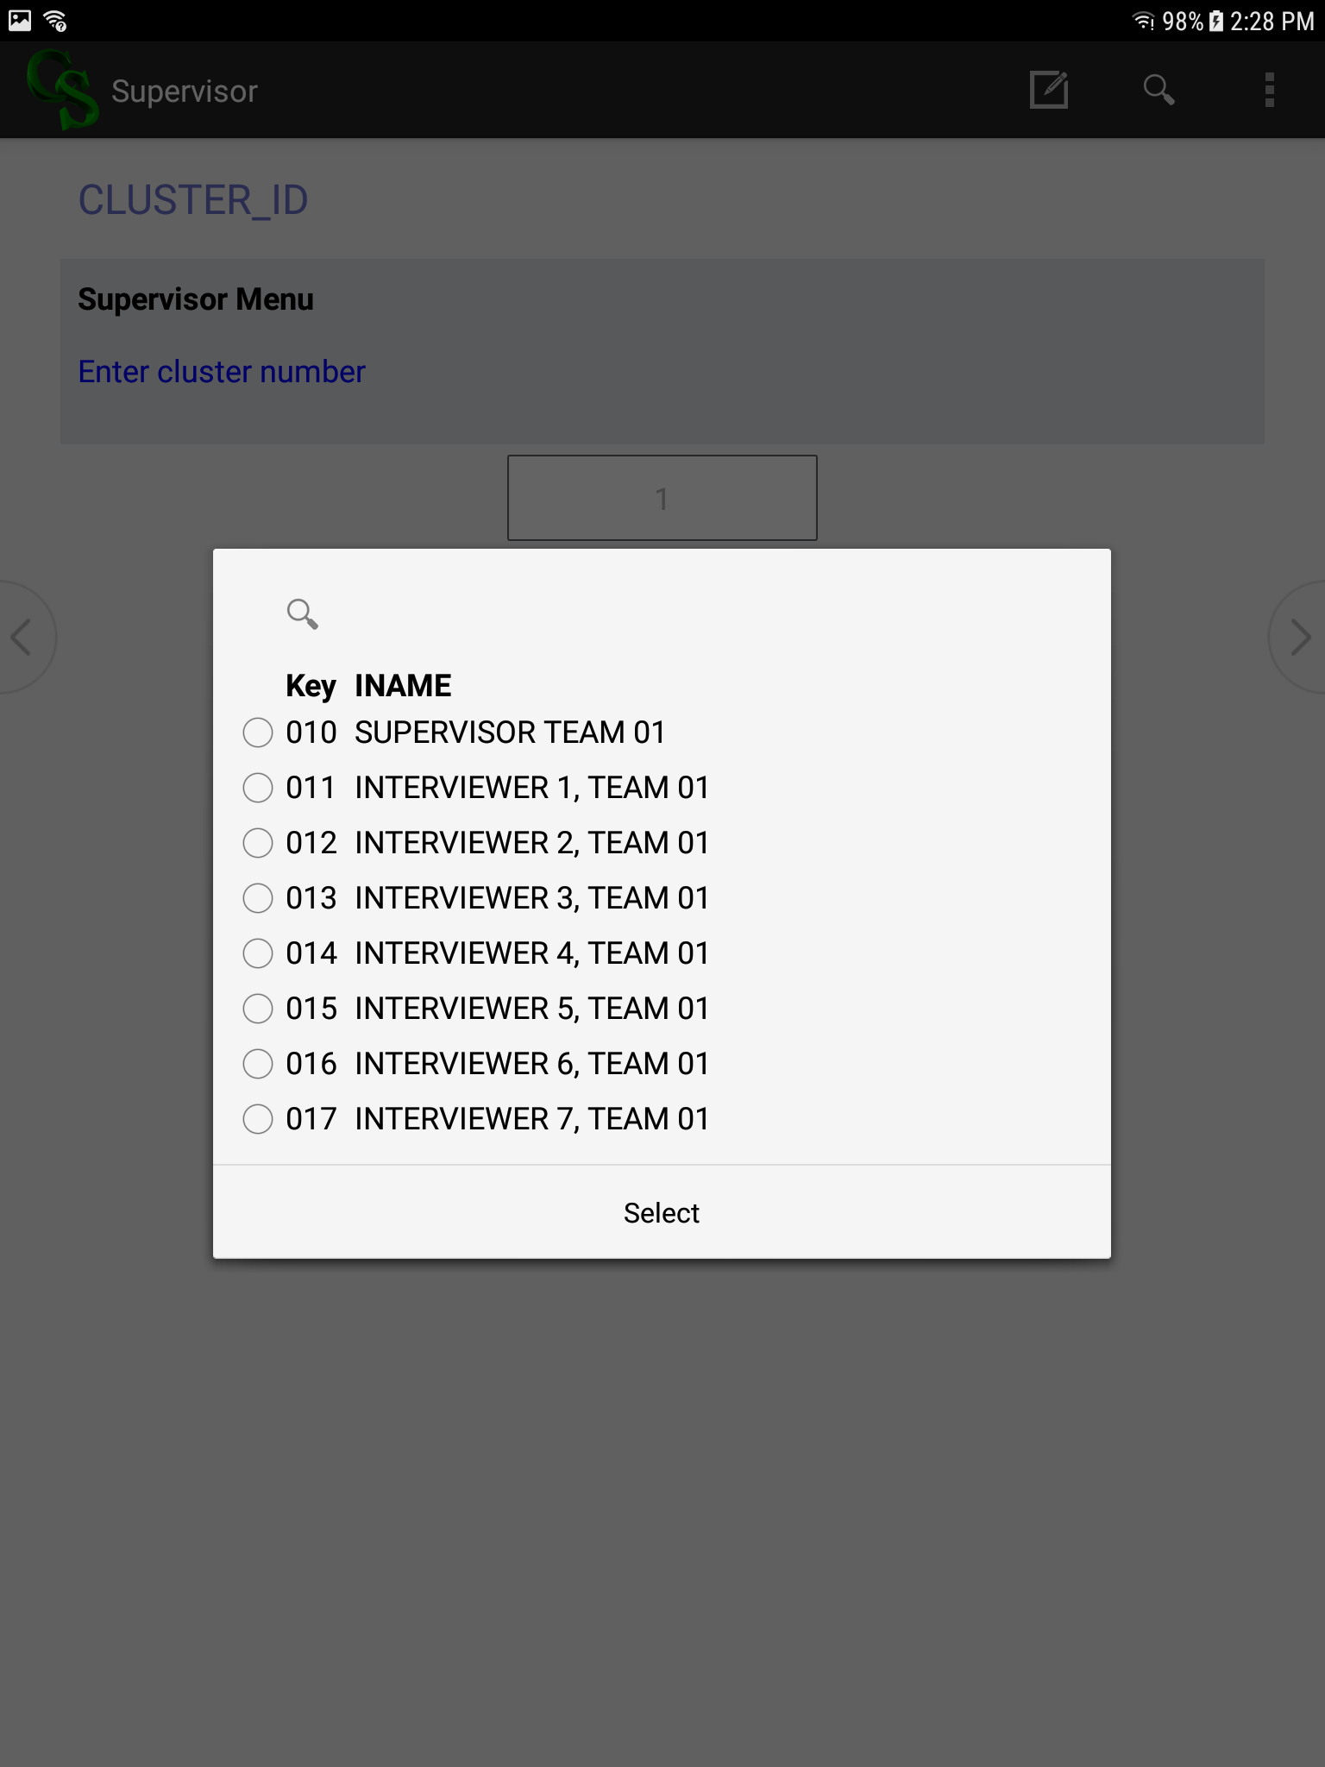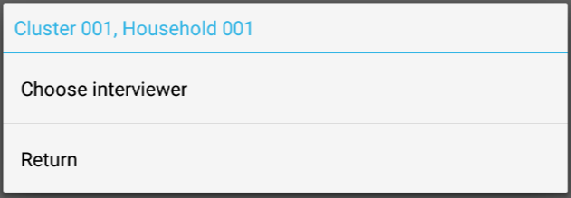

After the assignment, only that interviewer can lead data collection from the assigned household. The system is designed to avoid unwanted duplicates of households by assigning only one interviewer to a specific household. Once the field supervisor assigns a household to an interviewer (ex. code 111), only the assigned interviewer can select that household from their menu.

After the field supervisor assigns interviewers to households, he or she must transmit the updated household assignments to the interviewers by selecting option, **“6. Send updates to interviewers**” (Figure 3), on the Field Supervisor’s menu.

### 4.5.2 Assignment sheets

The field team must maintain complete records of work each day using the assignment sheets. The field supervisor must keep an accurate record of assignments on the supervisor’s assignment sheet (see Annex A).

To complete the supervisor’s assignment sheet, first the field supervisor will record the information for the selected households from the household cluster list, preferably in the same order in which they are listed on the household cluster list. The field supervisor first will list the household ID number and the name of a responsible adult in the household, if known. Then, for each household, the field supervisor will write the ID number of Interviewer A assigned to that household in CAPI. *[*Note*: The interviewer ID number and the ID number on his or her tablet are the same. Later, if a re-assignment is necessary, the field supervisor will strike through the row of the original assignment and then list the household ID number on a new row, adding the date of the re-assignment and the ID number of the Interviewer A, which will also be the new Interviewer A tablet ID number.]*

A re-assignment would be necessary if the interviewer team goes to a household and discovers that the one of the interviewers knows someone in the household. The interviewer team would then notify the field supervisor, and the field supervisor could re-assign the household to another interviewer on the field team and note the re-assignment on the supervisor’s assignment sheet and on the interviewers’ assignment sheets. If the secondary interviewer (B) knows someone in the household, the household would not need to be re-assigned, but the interview could not proceed at that time. Interviewer B would need to be replaced on the interviewer team working in that household. A re-assignment also would be necessary if Interviewer A does not speak the native language of the household roster respondent (see Section 4.3.3).

Each interviewer should maintain his or her own interviewer’s assignment sheet (see Annex B). The interviewer will track the status of each relevant survey module and eligible respondent in each assigned household. If a call-back visit is required, the interviewer will note the arrangements for this planned return date and time on his or her assignment sheet.

The field supervisor will review all interviewer’s assignment sheets each day. The field supervisor will carefully compare the information on the supervisor’s assignment sheet with the information on the interviewer’s assignment sheets to ensure consistency and accuracy. The field supervisor will track progress and plan fieldwork based on outstanding households and the need for call-backs.

Interviews that have not been completed for all eligible members of a household (i.e., households that require a call-back) are considered pending. Interviewer A and the agriculture interviewer should not submit the data or related paperwork – the anthropometry or plot/land area measurement forms – for that household for review until the entire questionnaire and all requisite modules are complete.

### 4.5.3 Language of the interview

The questionnaire will be administered in the native language of the respondent. The questionnaire has been translated into all languages that are the native languages of at least 10 percent of the population in the ZOI. In the ZOI of [COUNTRY], those languages are [LANGUAGES]. Field teams will be assigned to clusters based in part on the field team members’ language competencies.

As explained earlier, Interviewer A is assigned responsibility for beginning the interview with the household. On arriving at a household, it may be learned that the Interviewer A does not speak the language of the household or an eligible respondent in the household. There are several possibilities in this case:

*Scenario 1–Interviewer B speaks the respondent’s native language.* If Interviewer B speaks the respondent’s native language, responsibility for the household should be re-assigned to Interviewer B so Interviewer B becomes Interviewer A. The former Interviewer A would delete the cover sheet on his or her tablet. The supervisor will reassign the household to the new Interviewer A, who will complete the cover sheet on his or her tablet and start the interview, collecting all data on his or her tablet. The new Interviewer A would add the household to his or her interviewer’s assignment sheet and the former Interviewer A would cross the household off of his or her interviewer’s assignment sheet. The interviewer team would inform the field supervisor of the re-assignment so that the field supervisor can note it on the supervisor’s assignment sheet.

*Scenario 2–No one on the interviewer team speaks the native language of the respondents, but another interviewer on the field team does.* If neither Interviewer A nor Interviewer B speaks the language of the respondents in an assigned household, the interviewer team will notify the field supervisor. If another interviewer on the field team speaks the language of the respondents, the field supervisor will re-assign the household to that interviewer. This will be noted on the supervisor’s assignment sheet and on the interviewer’s assignment sheets.

*Scenario 3–No one on the field team speaks the native language of the respondent, but an interviewer on a nearby field team does.* If no one on the field team speaks the native language of a respondent, the field supervisor will ask the field manager to determine if any nearby field teams have an interviewer who speaks the language. If an interviewer with the required language capabilities is nearby, arrangements will be made to bring that interviewer to the cluster to complete the interview. That outside interviewer would accompany the original Interviewer A to the household, and would use the original Interviewer A’s tablet to complete the interview. Progress in completing the interview would be tracked on the original Interviewer A’s assignment sheet.

*Scenario 4–No one on the field teams in the cluster or in nearby clusters speaks the native language of the respondent.* If no one on the field team in the cluster or in nearby clusters speaks the native language of the respondent, the field supervisor will ask the field manager to arrange for an interpreter.Ideally, this interpreter would be from a local branch of the statistics office and have experience in conducting interviews on related topics. If such a person cannot be identified, then another interpreter should be identified. *[Note: This interpreter cannot be from the community because the interpreter might know the household member, thus violating confidentiality rules.]* In these cases, Interviewer A will return to the household with the interpreter. The interpreter will read the questions from the printed questionnaire or tablet, if a translation is available, and tell Interviewer A the respondent’s answers so Interviewer A can enter the responses into the tablet. If the respondent speaks a language other than one the questionnaire has been translated into, the interpreter would need to interpret each question for the respondent, and then interpret the respondent’s answers for Interviewer A. Interviewer A will work to ensure that the interpreter and the respondent both understand the questions and that the responses are interpreted accurately. Interviewer A would note the use of an interpreter in a comment at the end of the household form on the tablet. The household will continue to be assigned to the original Interviewer A, and all data for that household will be on his or her tablet.

### 4.5.4 Hidden households

The ZOI Survey is a survey of households. A household consists of adults and children that live together in the same dwelling. *[Note: More than one household can reside in a dwelling.]* They can be related or unrelated, but they should all meet these criteria:

* Acknowledge the same person or persons as lead decisionmakers for the household;
* Share the same housekeeping and cooking arrangements; and
* Share the same contiguous roof.

For the integrity of the survey, it is very important that every household in a selected cluster have an equal chance of being selected for an interview. Shortly before fieldwork, all households in the cluster are listed, and then households will be randomly selected from the list for inclusion in the survey. The ID numbers of selected households will be pre-loaded onto the tablets to create a questionnaire for each selected household.

In the course of fieldwork, it is possible that an interviewer team will discover a second or "hidden” household during a visit to a dwelling. “Hidden households” are individuals or families that reside under the same roof as the household listed on the interviewer’s assignment sheet, but (1) do not share cooking or housekeeping arrangements with that household, (2) recognize different lead decisionmakers for the household, and (3) were not counted during the listing exercise.

For example, if it is discovered that more than one *family* is living in a dwelling that was selected for interview, it is possible that there is more than one *household* living in the dwelling that may not have been counted during listing. It may also be discovered that a single person is living in the dwelling with the household selected for interview, but this person does not share cooking or housekeeping arrangements with the members of the selected household and makes his or her own decisions; this person may be categorized as a separate family or household, even though it is a family or household of only one person.

If a hidden household is discovered during fieldwork, the interviewer team must interview that household, in addition to the selected household assigned to the interviewer.

Because the tablet application has no ID for the hidden household, the following steps should be followed:

**Step 1:** The interviewer must confirm it is a hidden household, and that the household meets the following conditions:

* It is a household that resides under the same contiguous roof as the household selected for interview. This should be confirmed with the respondent by asking a question like: “Do the two families live under the same roof?”
* It is a household that does not share cooking or housekeeping arrangements with the household selected for interview. This should be confirmed with the respondent by asking a question like: “Do the two families share the same housekeeping and cooking arrangements?”
* Its members recognize different lead decisionmakers for the household. This should be confirmed with the respondent by asking a question like: “Do the two families acknowledge the same person or persons as lead decisionmakers for the household?”

**Step 2:** The field supervisor must confirm the final condition for being a hidden household—that the household was not identified during listing. The interviewer will inform the field supervisor that a hidden household seems to have been identified. The field supervisor will check the household listing data to confirm that, in fact, the household was not included during the listing exercise. *[Note: It is possible that a second household in a dwelling was identified during listing, but that second household was not selected for the survey. This second household is NOT a hidden household and it does not need to be interviewed.]*

**Step 3:** After the field supervisor has confirmed that a hidden household has been identified, the field supervisor must create an additional household in the sample file. *[Note: Interviewers are not allowed to create additional household entries by themselves. This must be controlled by the field supervisor.]* To create a separate household for data collection, the field supervisor will follow these directions:

* From the field supervisor main menu, select option “**10. Hidden households**” (Figure 3). To add a household, the field supervisor selects option “**1. Add hidden household**” (Figure 7). If a household was added in error, the field supervisor can remove it using option “**2. Delete hidden household**” in the same menu.

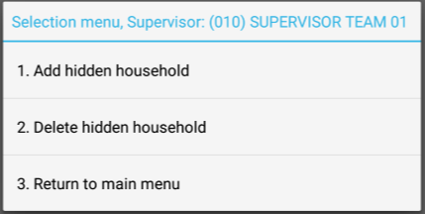

Figure 7: Screen shot of hidden household menu

* A list of available household numbers will appear—numbered 901-905 (Figure 8). The numbering of hidden households is the same in every cluster, which will not create duplicates since the full identifier for each household includes the cluster number as well. After choosing to add a household, the field supervisor will be prompted to add the household address and the name of the household head.

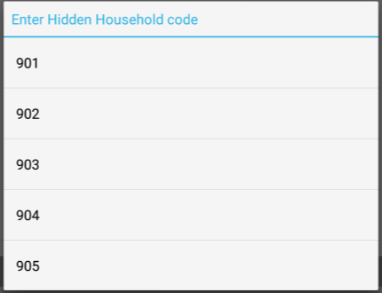

Figure 8: Screen shot of hidden household numbers

* The system will prompt to confirm the addition of the new hidden household (Figure 9)—confirm and the household is added to the sample. The field supervisor now must assign the hidden household to an interviewer (Option 2 in the Field Supervisor menu, Figure 3), selecting the new household from the bottom of the list of households (Figure 10).

Figure 10: Screen shot showing the newly added household, 901, at the bottom of the list of households

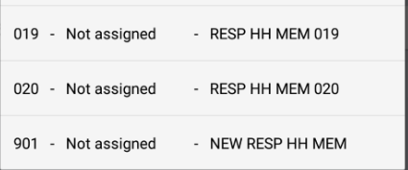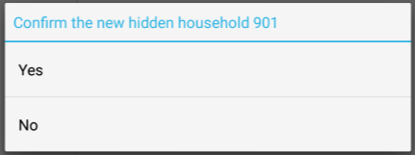

Figure 9: Screen shot of confirmation of hidden household

* Send the updated household assignment to the interviewers, using option **“6. Send updates to interviewers”** (Figure 3) as described previously.

**Step 4:** The field supervisor will add the new household to the supervisor’s assignment sheet, the interviewer will add the new household to the interviewer’s assignment sheet, the field supervisor will inform the field manager that a household has been added to the sample, and the field manager will inform Feed the Future [CONTRACTOR].

**Step 5:** The interviewer team will return to the dwelling to interview the hidden household. The interviewer team will select the ID number for the hidden household on the tablet to create the form for the new household.

## 4.6 Reduce non-response

To help ensure that the data collected in a household survey such as this are representative, it is important to collect data from all eligible household members in all selected households. Failure to do so will result in a high non-response rate and introduce bias to the survey findings. The field supervisor should emphasize to interviewers the importance of achieving a high response rate so that they push themselves to visit all selected households and to interview all eligible household members. This may mean that interviewers must return to a household several times, and at times when household members are available, not necessarily when it is convenient for the interviewers. The three types of non-responses are described below.

**Type 1 Non-response:** The interviewer is unable to locate or access the selected household.

* *Occupied structure inaccessible.* It may not be possible to reach a household due to impassable roads or rivers. If this is a widespread problem in a cluster, such as temporary flooding, the field supervisor should inform the field manager, who might re-assign the field team to another cluster while the transportation barrier in the first cluster is resolved. If it is a problem with just a few houses in the cluster, the field supervisor should send an interviewer team to the household later during fieldwork in that cluster if conditions have improved.
* *Structure not found.* The interviewer team, perhaps with the help of the driver, should make several attempts to locate the structure using the cluster map or satellite image and by asking neighbors. If the team cannot find the household structure, the field supervisor should attempt to locate the structure.
* *Structure non-residential, vacant, or demolished.* If the interviewer team indicates that a structure is not a dwelling unit, that it is vacant, or that it has been demolished, the field supervisor should verify that this is the case.

In each of these scenarios, although no interview has taken place, a household identification cover sheet should be completed for that household, with the appropriate result code. The same result code should be noted on the supervisor’s assignment sheet and the interviewer’s assignment sheet.

*[Note: A completed cover sheet is required for every selected household in a cluster. A field team will be sent back to a cluster to complete the cover sheet for any household if Feed the Future [CONTRACTOR] does not receive a completed cover sheet.]*

**Type 2 Non-response:** The interviewer is unable to locate an eligible respondent.

* *No one home at time of call.* If no one is in the house when the interviewer team arrives, the interviewers should try to find out from neighbors when the household members are likely to be home or how to contact them. Interviewers will visit the household at least three times to find someone at home. This may require visiting at mealtimes, in the early morning, in the evening, or on the weekend. It is not acceptable to make all three visits on the same day, except in cases where it is known that the household member or members will return that same day.
* *Respondent temporarily absent.* The interviewer team may be able to conduct part of the interview in a household but one or more of the eligible respondents may not be available during the first visit. In this case, arrangements should be made with the household to return when that missing member is expected to be available. It may not be possible to complete the interview with an eligible respondent, and it will be necessary to return to finish interviewing that respondent. In either scenario, Interviewer A should make up to three visits, preferably scheduled, to the household to complete the interview with all eligible household members. A different Interviewer B may accompany Interviewer A because the call-backs may occur on different days when interviewer teams have been configured differently, but all data for that household must be collected on the same interviewer’s (Interviewer A) tablet. The results of each visit should be noted on the interviewer’s assignment sheets each day that a visit is made to a household.

**Type 3 Non-response:** The respondent refuses to be interviewed. Some eligible respondents will be reluctant to be interviewed. Interviewers will be trained to minimize refusals. If the interviewer senses any hesitation on the part of the potential respondent, the interviewer should attempt in a friendly, non-coercive way to address the potential respondent’s concerns or questions. If there is a linguistic, ethnic, or personality barrier, either member of the interviewer team can attempt the interview, or see if the field supervisor can assign the household to a different interviewer. If it is an inconvenient time for the interview, the interviewer team should immediately offer to return at a better time and schedule a call-back. The field supervisor, as the more experienced interviewer, may need to interview a reluctant household or household member. The field supervisor should enter data on the Interviewer A’s tablet.

The field supervisor and the Feed the Future [CONTRACTOR] will monitor the number of refusals reported by each interviewer. The field supervisor will provide retraining or other support to any interviewer with a high refusal rate.

## 4.7 Monitor completion of assignments

Survey fieldwork has been carefully planned so that all data collection can be completed in the required timeframe. Each field team must play its part if the schedule is to be met. The field supervisor is responsible for adherence to the schedule in his or her clusters. The field supervisor should review the status of all assigned households every day with the interviewers and should assign up to three call-backs to a household to complete data collection. As household interviews are completed, the final status of each selected household should be noted on the supervisor’s assignment sheet, and this final status should match the final status for the last visit to that household as recorded on the interviewer’s assignment sheet.

## 4.8 Monitor and support interviewer performance

Controlling the quality of data collection is the most important function of the field supervisor. The field supervisor has the responsibility to observe and spot-check interviews to ensure that the quality of data collection remains high throughout the survey. The field supervisor will monitor and support interviewers’ performance primarily through observing interviews, spot-checking household rosters, and meeting with interviewers each day to discuss performance.

### 4.8.1 Observe interviews

Although all interviewers will have successfully completed training in interviewing procedures, understanding the questionnaire, and using the tablet before fieldwork begins, they are also vulnerable to misunderstandings or poor habits that can creep into their work. Some of these weaknesses can be detected during a review of their data, but many are not apparent from the data. Sometimes it is necessary to observe how an interviewer conducts an interview to identify some issues. The field supervisor will observe each interviewer several times each week as he or she is conducting interviews. Based on these observations, the field supervisor will be able to ensure that interviewers fully understand the survey procedures and standards and continue to adhere to them.

In the course of observing the interview, the field supervisor will not interrupt the interviewer to ask questions or attempt to provide training to the interviewer. Rather, the field supervisor will watch and note any issues that should be discussed with the interviewer after the interview. If, however, the field supervisor sees a serious problem, such as the interviewer failing to probe to ascertain a child’s age or administering the time use module incorrectly, the field supervisor should politely offer to assist with just that aspect of the interview.

The field supervisor should take note of the following points:

1. Did the interviewer introduce the survey objective clearly?
2. Did the interviewer obtain informed consent of each respondent before asking that respondent questions?
3. Did the interviewer show respect to the respondent, and acknowledge and respond to any respondent concerns or questions?
4. Did the interviewer follow all of the recommended procedures to probe household members’ ages?
5. Did the interviewer ask the questions as written?
6. Did the interviewer assess the respondent’s understanding of the question?
7. Did the interviewer use appropriate techniques for assisting recall?
8. Did the interviewer complete all questions?
9. Did the interviewer correctly identify the household members mainly responsible for cultivating or raising the VCCs?

Ideally, the field supervisor will speak the language in which the interview is being conducted. Even if the field supervisor does not speak the language, he or she should be able to detect many problems by watching how the interviewer conducts himself or herself, how he or she interacts with the respondent, and whether he or she takes care in entering data on the tablet. If the field supervisor is male, he should avoid observing survey module 6W interviews (these are interviews with female respondents to the empowerment in agriculture); however, he may observe during survey module 6M, interviews with male respondents to the empowerment in agriculture module.

The field supervisor should discuss the interviewer’s performance with him or her soon after leaving the household before any details of the interview are forgotten. The field supervisor should make a point of commenting on both the positive aspects of the interviewer’s work as well as areas that require improvement. The field supervisor should make sure the interviewer understands how to improve his or her performance, including by role playing the parts of the interview that were problematic. If the misunderstanding is demonstrated by several interviewers, the field supervisor should reiterate the correct procedures to the entire field team at a group meeting that week, without identifying the interviewer whose performance prompted the discussion.

It is very important that the field supervisor carefully observe and provide detailed feedback on each interviewer’s performance several times in the first week of fieldwork so that poor practices do not become ingrained. **It should not be assumed that interviewer’s performance will improve steadily over the course of fieldwork.** As the end of fieldwork approaches, interviewers may be pre-occupied with getting home or finishing their work and pay less attention to details. Thus, the field supervisor should continue to provide careful observation and detailed feedback up until the end of fieldwork.

### 4.8.2 Conduct a systematic spot-check of household composition

Survey modules 4, 4a, 5, 5a, and 6 are to be administered to household members who are eligible based at least in part on age. Interviewers may be tempted to subtract years from the age of a woman whose age is close to the lower boundary of eligibility (around 15 to 17 years), add years to the age of a woman whose age is close to the upper boundary of eligibility (around 50 to 55 years), or add years to the ages of children under 5 years to reduce the interviewing workload. This practice can have a substantial negative impact on the quality of the survey data.

To detect and prevent this kind of interviewer error, the field supervisor should regularly spot-check household composition. To conduct a spot-check, the field supervisor will return to certain households and independently collect the household roster data, writing the data on a printed *spot-check package*. The spot-check package consists of a blank cover sheet and a blank household roster (survey module 1). The field supervisor will follow these instructions:

* Write “SPOT CHECK” across the top of both pages in the spot-check package.
* Complete the household identification and geographic location portions of the cover sheet (items 01-07).
* Complete the following parts of the household roster: the name, relationship to the household primary decisionmaker, sex, age (items 101-104), and line numbers for children’s parent or guardian for all members of the household.
* Carefully probe the ages of household members who are close to the ages of eligibility for relevant survey modules:
  + For survey module 4, women listed as 11-14 years and 50-55 years in the household roster;
  + For survey module 5, dietary diversity, children listed as 3-4 years in the household roster;
  + For survey module 5a, anthropometry, children listed as 6-7 years in the household roster; and
  + For survey module 6, young women and men listed as 15-17 years in the household roster.

Subsequently, when the field supervisor meets with Interviewer A to review the household questionnaire for that household, the field supervisor will compare the household roster information he or she collected with the household roster information collected on the interviewer’s tablet.

The field supervisor will be responsible for conducting a spot-check of household composition in each cluster for each of the four interviewers. Households should not be selected randomly for these spot-checks. To the extent possible, the field supervisor should select households that contain women or children of borderline ages. The field supervisor will identify these households by checking the household roster on the interviewers’ tablets every day.

In the course of a spot-check, the field supervisor might discover a household member who was omitted from the household roster during the individual interview, or a household member who is age-eligible for survey modules 4, 4a, 5, 5a, 6M, or 6W but whose age was recorded as outside the range of eligibility in the original interview. The field supervisor must call the error to the interviewer’s attention, provide guidance on how to remedy the problem, and send the interviewer back to the household to collect or revise information for any survey modules affected by the household roster data collection error or omission.

The field supervisor should carefully review with the entire field team the procedures to probe for household members’ ages and remind the interviewers that intentional displacement of household members’ recorded ages outside the range of eligibility is grounds for dismissal from the team.

There are three possible scenarios that would require the interviewer to re-visit the household to revise the household roster and subsequent survey modules affected by the household roster data collection error or omission:

1. A woman or child was listed on the household roster and has an ID number, but the age information on the household roster was incorrect so a record for the woman or child was not created for survey modules 4, 4a, 5, 5a, 6M, or 6W. The interviewer team should correct the age information on the household roster, then advance to the appropriate survey module, select that respondent, confirm and obtain informed consent, and administer that survey module to that respondent.
2. A woman or child was *not* listed on the household roster and does *not* have an ID number. The interviewer team should add the woman or child at the end of the household roster, completing all roster information for this new household member. If the woman or child is eligible for survey modules 4, 4a, 5, 5a, or 6W, the interviewer should advance to the appropriate modules, select that respondent, confirm or obtain informed consent, and administer that survey module to that respondent.
3. A man was *not* listed on the household roster and does *not* have an ID number. The interviewer team should add the man at the end of the roster, completing all household roster information for this new household member. If the man is eligible for survey module 6M, the interviewer should advance to the appropriate survey module, select the male respondent, confirm or obtain informed consent, and administer that module to the male respondent.

The interviewer would need to revise his or her interviewer’s assignment sheet if the change to the household roster changes the survey modules that require completion, such as if it is learned that a call-back is necessary.

If new eligible household members are identified during a spot-check, the field supervisor should increase the frequency of spot-checks of that interviewer’s work until the field supervisor is comfortable that the interviewer is consistently adhering to procedures.

If a household roster is going to be spot-checked, the spot-check must take place *before* the household’s data are finalized and transmitted to Feed the Future [CONTRACTOR].

All field teams should keep in mind that Feed the Future [CONTRACTOR] data processing team will analyze the age distributions of household members recorded during fieldwork against normal age distributions to determine if there is observable displacement of household members’ ages beyond the upper and lower bounds of eligibility. These checks will identify systematic efforts by interviewers to reduce their workload by misreporting the ages of household members. Field supervisors will be informed immediately if such problems with any of their field team members’ data are identified so that steps can be taken to ensure that interviewers are not intentionally displacing the ages of household members. Field supervisors, however, should work to prevent, identify, and correct this age displacement before it is identified by the Feed the Future [CONTRACTOR] data processing team.

### 4.8.3 Conduct team meetings

The field team should meet every day at the end of the day or the next morning to review and discuss each day’s work. Table 2 shows a suggested agenda for these meetings.

Table 2: Suggested agenda for daily field team meetings

| **Time** | **Topic** |
| --- | --- |
| 0:00 | Welcome the team to the meeting and thank them for another day of hard work. |
| 0:05 | Success Stories: Field supervisor asks interviewers to share a success story from the day’s work. |
| 0:15 | Lessons Learned: Field supervisor asks interviewers to share a lesson learned from the day’s work.  A very good learning opportunity occurs when interviewers share situations that came up during interviews that they did not expect and were not sure how to handle. Interviewers should share the challenge they encountered, describe how they resolved the challenge, and ask the team for input on best approaches. The field supervisor should share these with the QCS team, which can include them in its report to survey management and the Feed the Future [CONTRACTOR] for incorporation into ongoing training.  If the team encounters problems in the field that were not addressed in the field manuals or training materials, the field supervisor should communicate these issues to the field manager right away and request guidance. |
| 0:45 | Interview Observations: Field supervisor praises good work that has been observed and discusses mistakes noticed during interview observations.  This should be seen as a learning opportunity for the team. Blame should not be assigned and mistakes should not be attributed to a particular interviewer so that individual team members are not embarrassed. Only cover those observations not already raised by interviewers during the lessons learned activity. Ask interviewers to read out loud selected passages from the Interviewer’s Manual to the team if pertinent to observed errors. |
| 1:00 | Data Issues: Field supervisor summarizes findings from data on the tablets, including praising high-quality data. Reports mistakes found during the review of interview data.  This should be seen as a learning opportunity for the team. Blame should not be assigned and mistakes should not be attributed to a particular interviewer so that individual team members are not embarrassed. |
| 1:15 | Overall Fieldwork Quality: Field supervisor shares the latest findings on fieldwork quality, such as response rates, identification of age displacement, or age heaping problems, received from the central office. Congratulate the team for positive or no findings; review procedures to improve performance related to negative findings. |
| 1:30 | Summary and Close: Field supervisor summarizes the positive aspects of the team’s work that day, reminds the team of performance issues to be addressed going forward, and thanks everyone again for another day of hard work. |

In the early days of fieldwork, these meetings can be expected to go beyond the suggested timeframe outlined in the suggested agenda in Table 2. Everyone is still learning and the field supervisor will need to spend a considerable amount of time and energy evaluating the team’s work, providing guidance and instruction, and following up on any observed problems. Adequate time should be dedicated to this until the field supervisor is certain that the team is getting the work right in every interview.

## 4.9 Motivate the field team

While fieldwork is often enjoyable and interesting, it also can be challenging. Team members are away from home, family, and friends for long periods of time, and the work can be both physically and emotionally stressful. At the same time, the team must function efficiently and collect high-quality data throughout the entirety of fieldwork. The key to obtaining the best results is to ensure that team members’ motivation to do excellent work remains high throughout the course of fieldwork.

The field supervisor’s technical and managerial role is well defined, but no less important is the field supervisor’s role in maintaining team motivation and morale. Team members will be inspired to do good work if they understand what is expected of them, are recognized for good work, and work with adequate and timely logistical and supervisory support. Additionally, however, team members should understand that their work is being monitored in the cluster by the field supervisor, as well as centrally by [SURVEY SUBCONTRACTOR] and Feed the Future [CONTRACTOR].

Interviewers should understand that careful review of their work, honest feedback, and open sharing of issues and lessons all contribute to the team’s performance. They should feel comfortable asking questions and admitting to mistakes so that they—and their peers—keep learning and improving. If field team leadership observes something done wrong, leadership should take a supportive rather than a punitive approach in addressing the issue with the interviewer. When discussing performance problems in the group meetings, the interviewer who exhibited the performance issue should not be identified.

The field supervisor should remember that his or her own behavior sets the standards for the team’s behavior. He or she should be punctual and responsible, be respectful of community members and all field team members, behave professionally in all interactions, work hard, and demonstrate commitment to all the procedures learned during training. The field supervisor’s commitment to quality will imbue the entire team with a commitment to quality.

Finally, the team’s accomplishments should be celebrated. Improvements in quality should be recognized and progress in completing the field team’s assigned work should be acknowledged.

## 4.10 Finalize work and close the cluster

Before leaving a cluster, the field supervisor should thank the local authorities for their cooperation and that of their community.

Also before leaving, the field supervisor should organize all documentation, and confirm that all data have been collected and transmitted to [SURVEY SUBCONTRACTOR]. The CAPI data collection system has a built-in check of the data in the cluster to confirm that all data has been collected and properly transmitted – this is a process called “closing clusters” and requires that no errors in the data structure remain. That is, the cluster should have no missing modules or interviews, no duplicated work, and all data must be properly transferred. To close a cluster in the CAPI system, the field supervisor should take these actions:

* Confirm that all selected households have been interviewed. The supervisor’s assignment sheet should show the final status of all selected households in the cluster. No households should be pending.

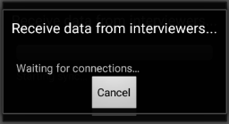

Figure 11: Screen shot of Bluetooth connection with interviewers

* Receive all complete questionnaires from interviewers. To do so, the supervisor should select option “**3. Receive questionnaires from interviewers**” (Figure 3), which opens the Bluetooth connection with interviewers (Figure 11).
* Combine all data from interviewers using option “**4. Concatenate data from current cluster**”.
* Attempt to close the cluster by selecting option “**1. Open/Close Cluster**” (Figure 3). Enter the cluster number to be closed. Because the cluster is open, the system will prompt to close the cluster—the supervisor should select yes (Figure 12). This will run a structure check program to confirm that all data was properly collected in the cluster.

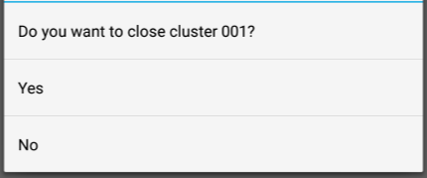

Figure 12: Screen shot of closing cluster dialogue box

When the supervisor runs the closing clusters program, a screen will appear alerting the supervisor to any errors in the structure of the data. If there are errors in the structure of the data, such as missing modules or households, the supervisor’s CAPI system will not close the cluster. An example of the closing clusters program results is shown in (Figure 13).

Figure 13: Screen shot of closing cluster results summary indicating missing or inconsistent data

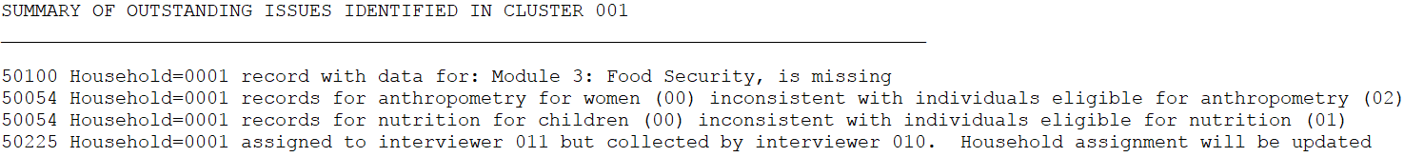

For every error in the results, the supervisor must lead the team to resolve it. It is only after a clean run of the closing clusters program has been produced can the supervisor close the cluster and move to the next. To resolve the errors in the summary, use the closing clusters guidelines in Annex G and follow the steps below:

* Identify the error code given on the left of the output (in Figure 12, error codes are 50100, 50054, and 50225).
* Refer to Annex G for an explanation of the error, reason it may be appearing, and guidance for how to resolve the issue. Most often, resolving an error requires an interviewer on the team to take action, such as revisit a household to collect data, resave a questionnaire that has been improperly saved, or enter missing anthropometry data.
* IMPORTANT: all interviewers who make any changes to the data must resend their data to the supervisor for changes to reflect in the closing clusters program.
* After all interviewers have made changes to their data and resent it, the supervisor should repeat the steps described previously – receive, concatenate, and re-attempt to close the cluster. If any errors remain, the supervisor must lead the team in resolving them.
* Once all errors have been resolved, all that will remain is a listing of the households and the applicable modules (Figure 14). The CAPI system automatically closes the cluster and the data can now be transferred to the central office.

Figure 14: Screen shot of closing cluster results summary indicating that there are no missing or incomplete data, and that the cluster can be closed.

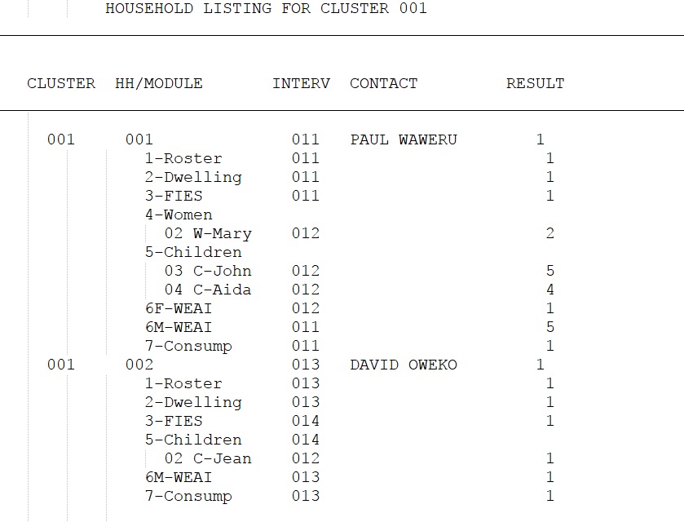

In addition, after the cluster has successfully closed, the field supervisor should:

* Select option “7. Prepare data for transmission to C.O.”, and subsequently option “8. Transmit data to Central Office”. Data will be transferred to a secure Dropbox location automatically. More information on transmission of the data to the in-country data manager is provided later in this document.
* Confirm with the in-country data manager that all household records have been transmitted electronically to the in-country data manager, if it is possible to transmit data from the cluster. The supervisor’s assignment sheet should show the date when each household’s data were transmitted.
* Verify that there is a backup of every completed household record on the field supervisor’s tablet.

The field supervisor should organize the following hard copy documents to be provided to the central office:

* Completed supervisor’s assignment sheet for the cluster, one per cluster;
* Completed interviewer’s assignment sheets for the cluster, one per interviewer per cluster; and
* Completed spot-check packages, one per household that was spot-checked.

The field supervisor will either deliver the forms to the central office, if the team is returning to the central office after completing work in the cluster, or provide the forms to the QCS team, which will deliver them to the central office.

# 5. Assure data quality and manage data

Data quality assurance and management involves four separate but related activities for household interviews that were completed, with no pending interviews, that day:

1. Field supervisor reviews the summary of data at the end of the household form to assess the interview’s completeness and the quality of certain data.
2. Field supervisor marks the household interview as finalized on the supervisor’s assignment sheet.
3. Interviewer A archives the data on his or her tablet and transmits the completed questionnaire to the field supervisor.
4. Field supervisor backs up the data on his or her tablet and on the thumb drive, and then transmits the completed questionnaires to the in-country data manager.

The field supervisor is responsible for completing these steps and reviewing the household form on the tablet, verifying that the data are acceptable, and completing the remaining steps of noting finalization, archiving, backing up, and transmitting the data. These activities are described in detail in the following section.

## 5.1 Review household form

After an interviewer considers a household interview to be complete (meaning that all eligible respondents have been interviewed or three attempts to interview each eligible respondent have been made), Interviewer A will transmit data from his or her tablet to the field supervisor’s tablet. The field supervisor will review the household form by referring to the summary at the end of the form. (Annex D shows a screen shot of the summary.) The summary includes household identification information and the status of each survey module for each household member who is age-eligible for a module based on the household roster. The summary also includes age and anthropometric data from each record in survey modules 4a and 5a.

### 5.1.1 Verify the households are complete

The field supervisor will confirm that the household is complete and the appropriate status is noted for all survey modules and module respondents using the summary screen produced upon receiving data from an interviewer. To do so, the field supervisor will take these two steps:

1. *Review household summary screen for each household.* An interview is considered *not conducted* if it was not possible to complete the cover, informed consent, and survey module 1 for that household. If the interview was categorized as *not conducted*, there should be a current result code to indicate the reason. For certain codes, such as *not home,* there should have been three attempts to conduct the interview.
2. *Verify completion of all relevant survey modules.* For interviews that were conducted, the field supervisor should review the status of each survey module and each module respondent.Beginning with survey module 2, for every module and every module respondent (more than one person could have been interviewed in a module, such as in survey modules 4 and 5) the field supervisor should confirm there is a result code. The household summary screen (Annex D) contains this information from the tablets, and the supervisor should cross-check with the paper assignment sheets to see that—
   * There is a survey module 6W in any household with a female primary decisionmaker.
   * There is a survey module 6M in any household with a male primary decisionmaker.
   * Every female household member age 15-49 years has data for survey modules 4 and 4a, even if the data are not complete.
   * Every child under 6 years has data for survey modules 5 and 5a, even if the data are not complete.

The result of each module is shown in the household summary screen, and the program checks to ensure that the results of each module coincide with the household roster and the eligibility of respondents. This means that if survey modules should be completed based on the household composition, data are present or an appropriate incomplete result code has been assigned (*postponed* is not a final result code and must be adjusted before work is complete).

The field supervisor will inform the interviewer of any discrepancies that need to be corrected. If any survey module that was expected is not included in the summary, or any result codes are missing, Interviewer A must return to the household with a second interviewer to complete the interview. This process is similar to closing clusters as described previously, allowing for the team to make corrections to the data before attempting to close. Review of this summary information should be done on a daily basis so that closing the cluster is as manageable a task as possible.

### 5.1.2 Confirm key height or length and weight variables

Four Feed the Future indicators[3] are calculated with anthropometric data. Because of the importance of the anthropometric data points, the field supervisor will carefully review all anthropometric data. The supervisor can easily review anthropometric data as interviewers send their data. The summary screen of household and module status (Annex D) will also present the height and weight data for eligible women and children, along with a flag for out-of-range data.

In this phase of the household form review, the field supervisor will confirm key height or length and weight variables for children and check to make sure these key variables are within acceptable ranges. The height or length and weight of each child with a record for survey module 5a, as shown in the summary at the end of the household form, will be compared to the expected height and weight of children of that age and sex, using the table in Annex E, *Expected Values for Height (Length) and Weight for Children 0-59 Months*. Any children whose height or weight fall outside of the appropriate ranges will be flagged for the supervisor to review carefully with the interviewer.

The field supervisor will similarly review the body mass index (BMI) of all women 15-49 years. The household summary form will report the BMI of each woman whose BMI is very low (< 16) or very high (> 35) on the Women’s BMI chart (see Annex F).

If a child’s or a woman’s anthropometric data are flagged as very low or very high, the field supervisor will discuss this with the household Interviewer B It is possible that the child or woman is very thin or very heavy and the values should remain as entered. The field supervisor should ask the interviewer if this was the case. If the interviewer does not recall that the child or woman was very thin or very heavy, the interviewer should return to the household to re-collect the anthropometric data.

### 5.1.3 Check for age heaping in children

Because the children’s anthropometric indicators are sensitive to a child’s age, it is important to record accurate ages for children. Some respondents will not know exact ages, and some interviewers may not want to go to the effort to carefully probe for children’s ages. These lapses may result in “age heaping,” or clumping of respondents’ ages on certain values. In the context of the ZOI Survey, age heaping might present itself as children reported to be 6 months, 12 months, 18 months, 24 months, 48 months, or 60 months. While a child actually may be one of those ages, it might also be the case that the interviewer did not probe carefully enough to ascertain the child’s true age. Children whose recorded ages may indicate age heaping will be noted on the household summary screen. The field supervisor should ask the interviewer about these children listed as 6 months, 12 months, 18 months, 24 months, 48 months, or 60 months old, and ask the interviewer to describe how he or she probed for that child’s age, or what documentation, if any, he or she saw of the child’s age. If the field supervisor does not believe the appropriate procedures were followed, the interviewer should be sent back to the household to re-collect the age data.

The field team should be aware that Feed the Future [CONTRACTOR] is regularly reviewing household records to identify possible age heaping and will discuss findings with [SURVEY SUBCONTRACTOR] management.

## 5.2 Archive data

Archiving data creates a second copy of the data on the interviewer’s tablet, but in a separate data folder. Data are archived after the field supervisor has reviewed the data and has deemed the household form “finalized.”

The field supervisor’s tablet has the complete household data as transmitted by the interviewers, the concatenated data to conduct the household review, and a set of all the data that remains in his or her tablet. This set of data remains in the field supervisor’s tablet throughout the data collection period.

The field supervisor will archive and transfer the data in two ways: (1) on an external memory flash drive, and (2) saved to a password protected Dropbox that can only be accessed by the field supervisor tablet, the ICDM, and the [CONTRACTOR] Data Manager. Data will not be stored in the Dropbox after the ICDM receives the data in the Central Office, minimizing the size of the Dropbox storage, as well as access to data.

### 5.2.1 Archive data on external memory flash drive

To archive the data on an external memory flash drive, the field supervisor and interviewer will follow these steps:

Select option “**11. Backup to external flash memory**” (Figure 3, Screen shot of supervisor’s main menu). This application creates an external backup for all data and control files. The application will prompt the field supervisor to confirm (Figure 15). Ensure the cable and flash memory drive are connected and tap on “Yes.” The application creates a header (folder) for each interviewer’s unique code, and the interviewer’s data are archived under that header/folder. After the data are archived and transferred successfully to the external memory flash drive, a message will appear to indicate that the process was successful. If for any reason the backup fails, the application will prompt and provide tools to the field supervisor to resolve the issue.

Figure 15: Screen shot of flash drive prompt

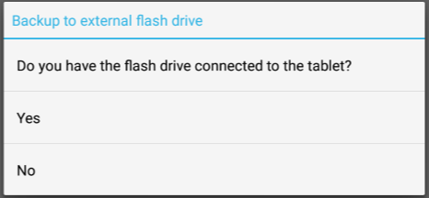

### 5.2.2 Archive data to Dropbox

To archive the data to Dropbox and transmit the data to the ICDM, the field supervisor will follow these steps:

1. Prepare the data for transmission to the Central Office (C.O.). This should be the entire data collected from a cluster.

2. Select option “**7. Prepare data for transmission to C.O.**” (Figure 3)

3. Select the data to be transmitted to the central office. The application will copy the selected data for transmission.

4. Verify the Internet connection is available and select option **“8. Transmit data to C.O.”** (Figure 3). Data are transmitted to the Central Office via Dropbox.

After the household form has been transmitted, the field supervisor should note the date of transmission in the “Date Transmitted” column on the supervisor’s assignment sheet.

It is important to note that transmitting data to Feed the Future [SURVEY SUBCONTRACTOR] can happen only if connectivity is available. If a connection is not available in the cluster, the field supervisor must wait until the field team is in a location with Internet access. At that point, the field supervisor should transmit all un-transmitted, final household forms from the previous cluster from the interviewers’ tablets. The field supervisor should transmit files as soon as Internet access is available, even if this requires delaying fieldwork slightly. The field supervisor may need to make a special trip to the closest location with cellular or Wi-Fi access to transmit files in a timely fashion.

# 6. Interactions with the central office and QCS teams

**Interactions with the field manager.** The field supervisor reports to the field manager and will have frequent interaction with the field manager throughout fieldwork. The field manager will assign clusters to field teams and monitor progress in completing clusters. The field manager will speak with the field supervisor, preferably daily during fieldwork, to discuss progress in the cluster, issues with data from the field team, any personnel or logistical issues, and any changes in procedures that have been requested or approved by Feed the Future [CONTRACTOR].

During the course of fieldwork, field supervisors will send completed paperwork from their team’s fieldwork to the field manager. If the field team is returning to the central office, the field supervisor will deliver this paperwork to the field manager. If the field team is moving on to another cluster rather than returning to the central office, the field supervisor will give the paperwork on completed clusters to the QCS team on its next visit to the field team. The QCS team then will deliver the paperwork to the field manager when it returns to the central office.

The field manager will retain all paperwork from fieldwork organized by cluster for easy reference, while Feed the Future [CONTRACTOR] cleans the data. Feed the Future [CONTRACTOR] will notify [SURVEY SUBCONTRACTOR] that this paperwork can be destroyed after data cleaning and analysis are finished. The field manager will see that this fieldwork documentation, which contains confidential information, is either burned or shredded. The field manager will notify Feed the Future [CONTRACTOR] after the destruction of the fieldwork documentation has been completed.

**Interactions with the data manager**. The data manager will review summaries of the data received by the Feed the Future [CONTRACTOR]. The data manager will then send the field supervisor reports that indicate problem areas, along with suggested ways to resolve the issues. Most often, these suggestions will include discussions with interviewers, but the data manager also may recommend additional interview observations by the field supervisor. Resolution of problems may require additional interviewer training or, in extreme cases, interviewer replacement.

**Interactions with the QCS team**. During fieldwork, the field team will receive a visit in the field ideally once a week, but at a minimum once every two weeks, from a QCS team. QCS teams will travel between the central office and the field teams. The QCS team will bring extra supplies, replacement equipment, and replacement team members, if needed. The QCS team may provide training to address interviewing challenges or any Feed the Future [CONTRACTOR]-approved revisions to procedures. The QCS team will share the field team’s field-check tables, obtained from the data manager, with the field supervisor.

The QCS team will review the work of the field supervisor by taking the following actions:

* Observe the field supervisor as assignments are discussed with interviewer teams and during team meetings.
* Compare the supervisor’s assignment sheet and the interviewer’s assignment sheets to confirm that the household assignments on the supervisor’s assignment sheet match the households listed on the interviewer’s assignment sheets and that the status of all households is consistent.
* Ensure the household roster spot-check forms were completed for at least one household for each interviewer each week and compare the information on the household roster spot-check form with the household roster on the final household form.
* Collect paperwork for any completed clusters for delivery to the central office.
* Answer any questions from the field supervisor or interviewers.
* Provide positive encouragement for the team and boost team morale.

# Annex A: Supervisor’s assignment sheet

|  |  |  |  |  |  |  |  |  |
| --- | --- | --- | --- | --- | --- | --- | --- | --- |
|  |  |  |  |  |  |  |  |  |

Date: ___________________________ Cluster Number: ___________________________

Supervisor Number: ___________________________ Page Number: ___________________________

|  |  |  |  |  |  |  |
| --- | --- | --- | --- | --- | --- | --- |
| **Household ID** | **Household Name** | **Date Assigned** | **Interviewer A and Tablet ID** | **Final Result** | **Date Finalized** | **Date Transmitted** |
|  |  |  |  |  |  |  |
|  |  |  |  |  |  |  |
|  |  |  |  |  |  |  |
|  |  |  |  |  |  |  |
|  |  |  |  |  |  |  |
|  |  |  |  |  |  |  |

# Annex B: Interviewer’s assignment sheet

Cluster Number: ________ Supervisor Number:_______ Page Number:______ Interviewer A and Tablet Number:_______

Interviewer B and Tablet Number:_______

| **HOUSE-HOLD**  **ID** | **INTER-VIEWER A** | **INTER-VIEWER B** | **VISIT RESULTS AND COMMENTS** | | | | |
| --- | --- | --- | --- | --- | --- | --- | --- |
|  |  |  | Date/Time of First Visit | Result | If partial complete, circle sections that still need to be completed:  1 2 3 4 4a 5 5a 6 7 8 | Comments | Date next visit scheduled |
|  | Date/Time of Second Visit | Result | If partial complete, circle sections that still need to be completed:  1 2 3 4 4a 5 5a 6 7 8 | Comments | Date next visit scheduled |
|  | Date/Time of Third Visit | Result | If partial complete, circle sections that still need to be completed:  1 2 3 4 4a 5 5a 6 7 8 | Comments |  |
|  |  |  | Date/Time of First Visit | Result | If partial complete, circle sections that still need to be completed:  1 2 3 4 4a 5 5a 6 7 8 | Comments | Date next visit scheduled |
|  | Date/Time of Second Visit | Result | If partial complete, circle sections that still need to be completed:  1 2 3 4 4a 5 5a 6 7 8 | Comments | Date next visit scheduled |
|  | Date/Time of Third Visit | Result | If partial complete, circle sections that still need to be completed:  1 2 3 4 4a 5 5a 6 7 8 | Comments |  |

# Annex C: Standard symbols used in cluster maps

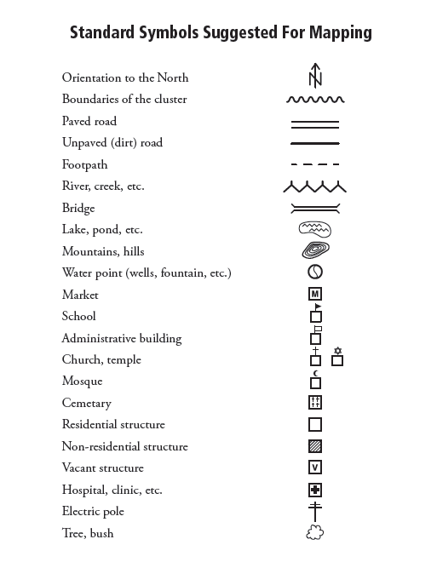

# Annex D: Screenshot of household summary

This annex contains an example of the summary screen displayed on the supervisor tablet when interviewers send their data to the supervisor.

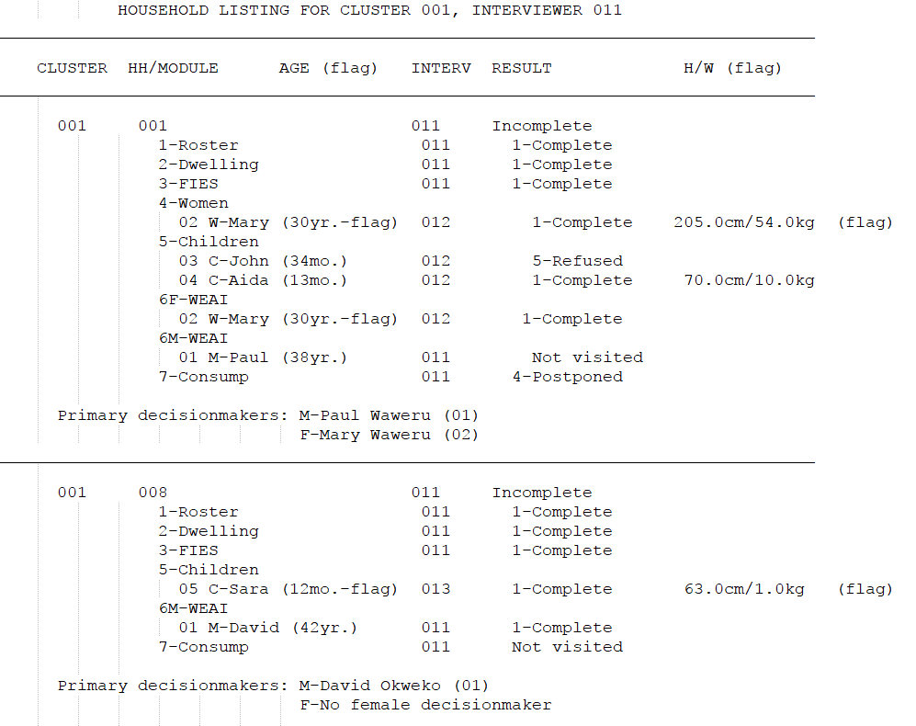

This summary gives the status of each household started by the interviewer and each of the modules and anthropometry data collections required. If the age is flagged for heaping or the height and weight is flagged as out of range, the supervisor should consult Annex E and discuss with the interviewer whether the data are valid. Revisits to the household may be required to check the quality of the data collection.

# Annex E: Minimum and maximum expected values for children’s height/length and weight

|  |  |  |  |  |  |  |  |  |
| --- | --- | --- | --- | --- | --- | --- | --- | --- |
| Age  in  months | Length (centimeters) | | | | Weight (kilograms) | | | |
| Male | | Female | | Male | | Female | |
| Minimum | Maximum | Minimum | Maximum | Minimum | Maximum | Minimum | Maximum |
| 0–2 | 36.0 | 74.0 | 36.0 | 72.0 | 0.5 | 10.0 | 0.5 | 9.0 |
| 3–5 | 45.0 | 83.0 | 44.0 | 80.0 | 1.0 | 13.0 | 1.0 | 12.0 |
| 6–8 | 51.0 | 87.0 | 50.0 | 86.0 | 2.0 | 15.0 | 2.0 | 14.0 |
| 9–11 | 56.0 | 91.0 | 54.0 | 90.0 | 3.0 | 16.5 | 2.5 | 15.5 |
| 12–14 | 59.0 | 96.0 | 57.0 | 95.0 | 4.0 | 17.5 | 3.0 | 16.5 |
| 15–17 | 62.0 | 100.0 | 60.0 | 99.0 | 4.0 | 18.5 | 3.5 | 17.5 |
| 18–20 | 64.0 | 104.0 | 62.0 | 102.0 | 4.0 | 19.5 | 3.5 | 18.5 |
| 21–23 | 65.0 | 107.0 | 64.0 | 106.0 | 4.5 | 20.5 | 4.0 | 19.5 |
| 24–26 | 67.0 | 108.0 | 66.0 | 107.0 | 4.5 | 23.0 | 4.5 | 21.5 |
| 27–29 | 68.0 | 112.0 | 68.0 | 111.0 | 5.0 | 24.0 | 5.0 | 23.0 |
| 30–32 | 70.0 | 115.0 | 69.0 | 114.0 | 5.0 | 24.5 | 5.0 | 24.5 |
| 33–35 | 71.0 | 118.0 | 71.0 | 117.0 | 5.0 | 25.5 | 5.0 | 25.5 |
| 36–38 | 73.0 | 121.0 | 72.0 | 120.0 | 5.0 | 26.0 | 5.0 | 27.0 |
| 39–41 | 74.0 | 124.0 | 74.0 | 122.0 | 5.0 | 27.0 | 5.0 | 28.0 |
| 42–44 | 75.0 | 127.0 | 75.0 | 124.0 | 5.0 | 28.0 | 5.5 | 29.0 |
| 45–47 | 77.0 | 129.9 | 77.0 | 126.0 | 5.0 | 29.0 | 5.5 | 30.0 |
| 48–50 | 78.0 | 132.0 | 78.0 | 129.0 | 5.0 | 30.0 | 5.5 | 31.0 |
| 51–53 | 79.0 | 134.0 | 79.0 | 131.0 | 5.0 | 31.0 | 5.5 | 32.0 |
| 54–56 | 80.0 | 136.0 | 81.0 | 133.0 | 5.5 | 32.0 | 6.0 | 33.0 |
| 57–60 | 82.0 | 139.0 | 81.0 | 136.0 | 5.5 | 33.0 | 6.0 | 34.5 |

# Annex F: Women’s BMI chart

(Values in the shaded regions are considered extreme BMI values for women (<16 and >35 kg/m2)

| Cms |  | 130 | 135 | 140 | 145 | 150 | 155 | 160 | 165 | 170 | 175 | 180 | 185 | 190 | 195 | 200 | 205 |
| --- | --- | --- | --- | --- | --- | --- | --- | --- | --- | --- | --- | --- | --- | --- | --- | --- | --- |
| Kgs |  |  |  |  |  |  |  |  |  |  |  |  |  |  |  |  |  |
| 39 |  | 23.1 | 21.4 | 19.9 | 18.5 | 17.3 | 16.2 | 15.2 | 14.3 | 13.5 | 12.7 | 12.0 | 11.4 | 10.8 | 10.3 | 9.8 | 9.3 |
| 42 |  | 24.9 | 23.0 | 21.4 | 20.0 | 18.7 | 17.5 | 16.4 | 15.4 | 14.5 | 13.7 | 13.0 | 12.3 | 11.6 | 11.0 | 10.5 | 10.0 |
| 45 |  | 26.6 | 24.7 | 23.0 | 21.4 | 20.0 | 18.7 | 17.6 | 16.5 | 15.6 | 14.7 | 13.9 | 13.1 | 12.5 | 11.8 | 11.3 | 10.7 |
| 48 |  | 28.4 | 26.3 | 24.5 | 22.8 | 21.3 | 20.0 | 18.8 | 17.6 | 16.6 | 15.7 | 14.8 | 14.0 | 13.3 | 12.6 | 12.0 | 11.4 |
| 51 |  | 30.2 | 28.0 | 26.0 | 24.3 | 22.7 | 21.2 | 19.9 | 18.7 | 17.6 | 16.7 | 15.7 | 14.9 | 14.1 | 13.4 | 12.8 | 12.1 |
| 54 |  | 32.0 | 29.6 | 27.6 | 25.7 | 24.0 | 22.5 | 21.1 | 19.8 | 18.7 | 17.6 | 16.7 | 15.8 | 15.0 | 14.2 | 13.5 | 12.8 |
| 57 |  | 33.7 | 31.3 | 29.1 | 27.1 | 25.3 | 23.7 | 22.3 | 20.9 | 19.7 | 18.6 | 17.6 | 16.7 | 15.8 | 15.0 | 14.3 | 13.6 |
| 60 |  | 35.5 | 32.9 | 30.6 | 28.5 | 26.7 | 25.0 | 23.4 | 22.0 | 20.8 | 19.6 | 18.5 | 17.5 | 16.6 | 15.8 | 15.0 | 14.3 |
| 63 |  | 37.3 | 34.6 | 32.1 | 30.0 | 28.0 | 26.2 | 24.6 | 23.1 | 21.8 | 20.6 | 19.4 | 18.4 | 17.5 | 16.6 | 15.8 | 15.0 |
| 66 |  | 39.1 | 36.2 | 33.7 | 31.4 | 29.3 | 27.5 | 25.8 | 24.2 | 22.8 | 21.6 | 20.4 | 19.3 | 18.3 | 17.4 | 16.5 | 15.7 |
| 69 |  | 40.8 | 37.9 | 35.2 | 32.8 | 30.7 | 28.7 | 27.0 | 25.3 | 23.9 | 22.5 | 21.3 | 20.2 | 19.1 | 18.1 | 17.3 | 16.4 |
| 72 |  | 42.6 | 39.5 | 36.7 | 34.2 | 32.0 | 30.0 | 28.1 | 26.4 | 24.9 | 23.5 | 22.2 | 21.0 | 19.9 | 18.9 | 18.0 | 17.1 |
| 75 |  | 44.4 | 41.2 | 38.3 | 35.7 | 33.3 | 31.2 | 29.3 | 27.5 | 26.0 | 24.5 | 23.1 | 21.9 | 20.8 | 19.7 | 18.8 | 17.8 |
| 78 |  | 46.2 | 42.8 | 39.8 | 37.1 | 34.7 | 32.5 | 30.5 | 28.7 | 27.0 | 25.5 | 24.1 | 22.8 | 21.6 | 20.5 | 19.5 | 18.6 |
| 81 |  | 47.9 | 44.4 | 41.3 | 38.5 | 36.0 | 33.7 | 31.6 | 29.8 | 28.0 | 26.4 | 25.0 | 23.7 | 22.4 | 21.3 | 20.3 | 19.3 |
| 84 |  | 49.7 | 46.1 | 42.9 | 40.0 | 37.3 | 35.0 | 32.8 | 30.9 | 29.1 | 27.4 | 25.9 | 24.5 | 23.3 | 22.1 | 21.0 | 20.0 |
| 87 |  | 51.5 | 47.7 | 44.4 | 41.4 | 38.7 | 36.2 | 34.0 | 32.0 | 30.1 | 28.4 | 26.9 | 25.4 | 24.1 | 22.9 | 21.8 | 20.7 |
| 90 |  | 53.3 | 49.4 | 45.9 | 42.8 | 40.0 | 37.5 | 35.2 | 33.1 | 31.1 | 29.4 | 27.8 | 26.3 | 24.9 | 23.7 | 22.5 | 21.4 |
| 93 |  | 55.0 | 51.0 | 47.4 | 44.2 | 41.3 | 38.7 | 36.3 | 34.2 | 32.2 | 30.4 | 28.7 | 27.2 | 25.8 | 24.5 | 23.3 | 22.1 |
| 96 |  | 56.8 | 52.7 | 49.0 | 45.7 | 42.7 | 40.0 | 37.5 | 35.3 | 33.2 | 31.3 | 29.6 | 28.0 | 26.6 | 25.2 | 24.0 | 22.8 |
| 99 |  | 58.6 | 54.3 | 50.5 | 47.1 | 44.0 | 41.2 | 38.7 | 36.4 | 34.3 | 32.3 | 30.6 | 28.9 | 27.4 | 26.0 | 24.8 | 23.6 |
| 102 |  | 60.4 | 56.0 | 52.0 | 48.5 | 45.3 | 42.5 | 39.8 | 37.5 | 35.3 | 33.3 | 31.5 | 29.8 | 28.3 | 26.8 | 25.5 | 24.3 |
| 105 |  | 62.1 | 57.6 | 53.6 | 49.9 | 46.7 | 43.7 | 41.0 | 38.6 | 36.3 | 34.3 | 32.4 | 30.7 | 29.1 | 27.6 | 26.3 | 25.0 |
| 108 |  | 63.9 | 59.3 | 55.1 | 51.4 | 48.0 | 45.0 | 42.2 | 39.7 | 37.4 | 35.3 | 33.3 | 31.6 | 29.9 | 28.4 | 27.0 | 25.7 |
| 111 |  | 65.7 | 60.9 | 56.6 | 52.8 | 49.3 | 46.2 | 43.4 | 40.8 | 38.4 | 36.2 | 34.3 | 32.4 | 30.7 | 29.2 | 27.8 | 26.4 |
| 114 |  | 67.5 | 62.6 | 58.2 | 54.2 | 50.7 | 47.5 | 44.5 | 41.9 | 39.4 | 37.2 | 35.2 | 33.3 | 31.6 | 30.0 | 28.5 | 27.1 |
| 117 |  | 69.2 | 64.2 | 59.7 | 55.6 | 52.0 | 48.7 | 45.7 | 43.0 | 40.5 | 38.2 | 36.1 | 34.2 | 32.4 | 30.8 | 29.3 | 27.8 |
| 120 |  | 71.0 | 65.8 | 61.2 | 57.1 | 53.3 | 49.9 | 46.9 | 44.1 | 41.5 | 39.2 | 37.0 | 35.1 | 33.2 | 31.6 | 30.0 | 28.6 |
| 123 |  | 72.8 | 67.5 | 62.8 | 58.5 | 54.7 | 51.2 | 48.0 | 45.2 | 42.6 | 40.2 | 38.0 | 35.9 | 34.1 | 32.3 | 30.8 | 29.3 |
| 126 |  | 74.6 | 69.1 | 64.3 | 59.9 | 56.0 | 52.4 | 49.2 | 46.3 | 43.6 | 41.1 | 38.9 | 36.8 | 34.9 | 33.1 | 31.5 | 30.0 |

# Annex G: Closing clusters guidelines

This annex contains guidance for resolving errors encountered in closing clusters. Using the error code on the left of the screen, follow the guidance outlined in this Annex G.



**50051 (Household=*nnn*) Number of women eligible in household schedule for M-4 (*n*) is inconsistent with total number of eligible women completed (*n*)**

This error occurs when women eligible for individual interview have not yet been interviewed for Module 4. To resolve, enter a final result code for the module and/or interview the eligible woman (women). This must be done on the interviewer’s computer and then data must be re-sent to the supervisor.

**50052 (Household=nnn) Number of children eligible in household schedule for M-5 (n) is inconsistent with total number of eligible children completed (n)**

This error occurs when children eligible for a caregiver’s interview have not yet been interviewed for Module 4. To resolve, enter a final result code for the module and/or interview the eligible children’s caregiver(s). This must be done on the interviewer’s computer and then data must be re-sent to the supervisor.

**50054 (Household=nnn) Number of women/children eligible in household schedule for anthropometry (n) is inconsistent with total number of women/children completed for anthropometry (n)**

This error occurs when persons eligible for anthropometry data collection have not yet been measured OR have been measured but the information collected has not yet been entered into the data entry form by the interviewer responsible for the module. To resolve, the interviewer assigned to the module must visit eligible household members and complete an anthropometry questionnaire, including in cases of absent persons, refusals, or other issues.

**50055 (Household=nnn) Household questionnaire partially completed, structure will not be checked at this time**

This error occurs when a household questionnaire has been exited in the middle of the data collection (during initial entry OR during a modification) and the case was saved partially. If the household has in fact been completed, it is likely that the interviewer re-opened the household to check the data or make a modification and did not advance to the end of the questionnaire before closing. If household is complete, this error is resolved by opening the household interview with the “modify” option on the interviewer menu, and advancing to the end of the questionnaire (done quickest by using F10 to advance to the end). If the interview is partially complete, then it must be completed before closing. Data must be resent to the supervisor to resolve the error.

**50100 (Household=nnn) Record with data for Module *n* is missing**

This error is produced when data that is expected to exist for a given module is missing. That is, the module has not been opened and a visit has not been attempted. The required modules are determined from the household roster module. To resolve, open the module to carry out an interview. If the interview cannot be completed, enter an incomplete result code. Data must be resent to the supervisor to resolve the error.

**50110 (Household=nnn) Incomplete household (result=*n*), but there are modules completed that shouldn't exist**

This error is produced when an incomplete result code for the household has been entered (codes 2-96), yet data beyond the result code for the interview has been entered. To resolve, open the household interview and choose to enter data for Module 1. Reenter the valid incomplete code, and immediately close the questionnaire if it does not already automatically do so. If module data entered are correct and valid, enter code 1 and advance to the end (F10) to continue work in the household.

**50151 The number of households completed (*n*) is correct, but there are still errors that need to be resolved**

This is a summary error – if any errors still exist, this message will appear.

**50200 (Household=nnn) Module *n* is partially completed, structure will not be checked at this time**

This error occurs when a module has been exited in the middle of the data entry (during initial entry OR during a modification) and the case was saved partially. If the module was in fact completed, it is likely that the interviewer re-opened the module to check the data or make a modification and did not advance to the end of the questionnaire before closing. If the interview was complete, this error is resolved by opening the interview with the modify option on the interviewer menu, and advancing to the end of the questionnaire (done quickest by using F10 to advance to the end). If the module is partially complete, then it must be completed before closing.

**50203 (Household=nnn) One or more mandatory modules is missing**

For households that are complete, all questionnaire modules must be completed where data are expected. If, for example, there is no primary female decisionmaker in the house, the female Module 6 will not be completed. However, all other modules for which eligible household members exist must be completed. If this is not the case, this error will appear. Complete the missing modules, navigate to the end of the questionnaire using F10 again, and close out. Data must be resent to the supervisor.

1. CONTRACTOR refers to the project or organization that has been awarded to conduct the Feed the Future Zone of Influence survey.
2. SURVEY SUBCONTRACTOR refers to the in-country implementing agency responsible for conducting the Feed the Future Zone of Influence survey.
3. The Feed the Future indicators that rely on anthropometric data are underweight in women of reproductive age, and underweight, stunting, and wasting in children under 5 years.